THE COURIER

**[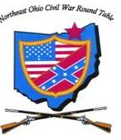](http://neocwrt.org/wordpress/wp-content/uploads/2010/03/NEOCWRT-logo-with-name1.jpg) Northeast Ohio Civil War Round Table**

**2019 SUMMER EDITION**

**The NEOCWRT Eighth Annual Symposium**

***Proudly Presents***

**A ONE-ACT PLAY**

**LINCOLN’S LAST DEBATE**

**A CONFRONTATION AT HAMPTON ROADS**

***When & Where***

Friday 7-9pm, July 5, 2019

James A. Garfield National Historic Site

*Visitor Center*

*8095 Mentor Avenue, Mentor*

*\*No Reservations Required\**

*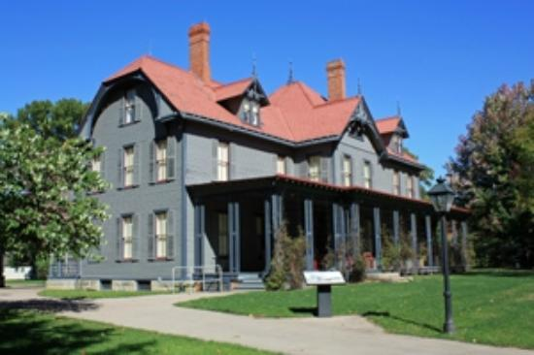[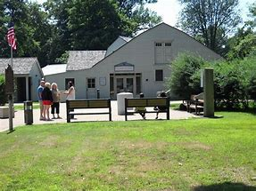](https://www.bing.com/images/search?view=detailV2&ccid=BEUIlWfU&id=235A3C839EBC246FBCCBE34E11E0072B4D9A46EF&thid=OIP.BEUIlWfUTypXpGPN508b4QHaFj&mediaurl=http://media-cache-ec0.pinimg.com/736x/07/5e/fc/075efc2a285169c0254109a5daf54c0b.jpg&exph=516&expw=688&q=james+a+garfield+national+historic+site&simid=608033944833559703&selectedIndex=13)*

*Setting: Early February, 1865* - Presidents Abraham Lincoln & Jefferson Davis, along with members of their respective governments, are attending a Peace Conference at Hampton Roads, Virginia. The Conference takes place aboard Lincoln’s Presidential Steamboat, the *River Queen.*

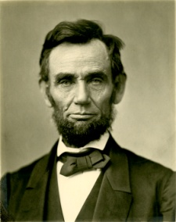During a recess, most of the conferees go to the bar for liquid refreshments. Unbeknownst to each other, the two Presidents seek solitude by repairing to the dining area. Stephen Boyd, a Cleveland Plain Dealer reporter, is aboard for the purpose of covering the event for his newspaper. He is reviewing his notes as the two Presidents enter the room. He approaches them and asks if he might interview them for the purpose of ascertaining their views on the causes and conduct of the war, and its likely outcome. Both Presidents graciously agree. They all sit down at a table and the interview begins, more civilly at first, less so as it goes on.

**The Cast:**

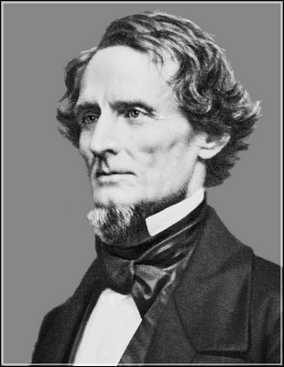Abraham Lincolnis portrayed by **Mel Maurer**, past president and Historian of the Cleveland Civil War Roundtable. Now retired, he speaks and writes often, particularly about the 16th President.

**John Fazio** plays Jefferson Davis.He has retired from the practice of law, but not from his interest in Civil War history. He lectures widely, including at the Chautauqua Institution in New York, and has written numerous articles and a book about the War of the Rebellion.

**Norton London**, a founding member of the NEOCWRT, plays Plain Dealer reporterStephen Boyd. “Norty” has taught 19th century American history at Lakeland CC, Cuyahoga CC and Baldwin Wallace University in their older adult programs.

Around Town

*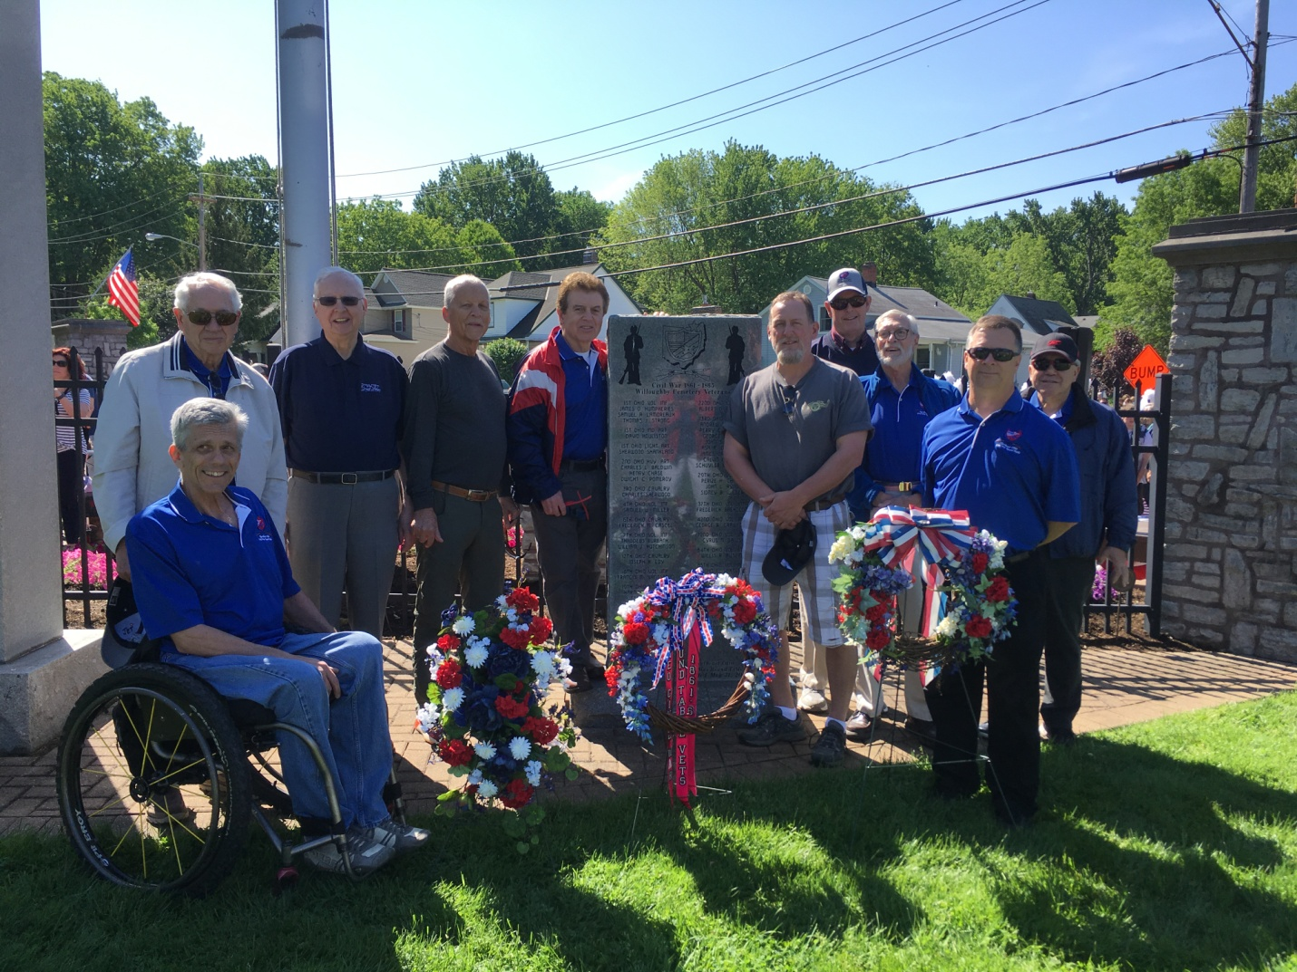Memorial Day*

Our club was well represented this year at Willoughby’s Memorial Day Services with its largest representation to date since the original dedication in 2003. Pictured here are *Scott Hagara, Joe Tirpak, Charles Stenger, Craig Stenger, Franco, Kenny Godnavec, Steve Abbey, Bill Meissner, Tom Horvath Jr.,* and *John Sandy.*

Special thanks to photographer *Cherie Godnavec!*

# Discovery of Civil War Graves in France

*By Paul Siedel*

Several weeks ago I happened to become engaged in a discussion with Pete Donatucci at the monthly meeting of the Quincy Gilmore C.W.R.T. in Elyria. He mentioned to me that he had been to Europe and had visited some Civil War graves in Cherbourg. He said that they were U.S. and Confederate sailors who had been killed in 1864. For a split second I thought to myself what Civil War action had taken place in Cherbourg in 1864. Then it hit me, the sinking of the Confederate raider the *CSS “Alabama”* by *the USS “Kersarge”*! It seems, as I learned, that the sailors that were killed that fateful day are buried in the city cemetery at Cherbourg, France, a fact that was totally new to me. Here is how it all came down:

On July 29, 1862 a newly built steam-powered cruiser called the “*Enrica*” left the Liverpool shipyard of the Laird Brothers. She was equipped with two 300 horsepower steam engines and, among other things, a large water conversion device that desalinated sea water, making it possible for her to be at sea for months at a time living off the booty captured from northern merchant vessels. She steamed out into the Irish Sea, around the northern coast of Ireland, and out into the North Atlantic. So began the notorious career of a steamer that would soon have a new name.

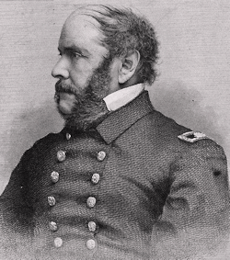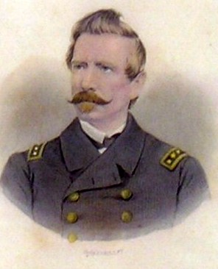She was next seen steaming into port in the Azores, the Portuguese Islands in the Atlantic. Here she took on coal, supplies, a mostly English crew and her new commander, *Captain Raphael Semmes*. Semmes had been a lawyer in Mobile before the War and so he immediately rechristened his new ship the “*Alabama”.* For the next two years she roamed the seas at will, sinking fifty-eight U.S. merchant vessels valued at over $6,500,000. Insurance rates were driven up so high that cargoes could not be sold for a profit. The *Alabama* had to be stopped. After sinking ships off the coasts of Texas, Brazil, Cape Town, Santo Domingo and Jakarta she put in for repairs at the small port of Cherbourg, France. She had barely arrived in Cherbourg when the U.S. counsel telegraphed the ambassador in Paris, who then contacted *Captain John Winslow* of the USS “Kearsarge”, a U.S. Naval vessel lying in wait off the coast of Holland. Winslow immediately steamed over to Cherbourg and dropped anchor at the entrance to the harbor. Unless the *Alabama* could fight her way out, her career was over. Early in June Captain Semmes steamed out into the open ocean and challenged the *Kearsarge* to a running duel. The two ships were evenly matched 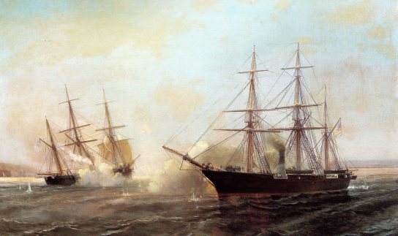and were nearly the same weight but the *Kearsarge* had gunners that were much more experienced than those of the *Alabama*. Soon the Confederate ship was in trouble, taking on water that flooded her engines and consequently rendered her helpless. Captain Semmes finally gave the order to abandon ship. He and several others were picked up by the British yacht “*The Deerhound*” which took them to Portsmouth, England. Union losses were one killed and three wounded. Confederate losses were nine killed and twenty-one missing or wounded. These are some of the men who rest eternally in their own small section of the Cherbourg Cemetery. Semmes eventually made his way back to Richmond where he commanded the cadets aboard the *CSS “Patrick Henry*”.

Confederate raiders did much damage to the U.S. merchant fleet. Ships such as “The Florida”*, “The Nashville”, “The Tallahassee” and “The Shenandoah”* destroyed millions of dollars worth of U.S. shipping during the Civil War. The reign of terror finally came to an end in November 1865 when crew members aboard *The Shenandoah* learned of Lee’s surrender from captured newspapers. The ship docked at Liverpool, lowered their flag, and the crew walked off the ship and into history. The Confederacy’s campaign against U.S. shipping was ended.

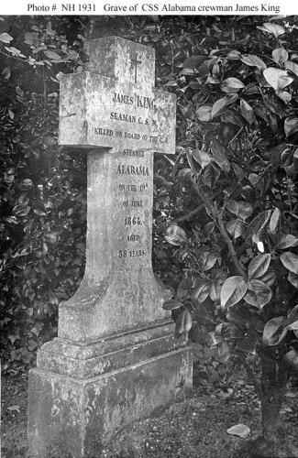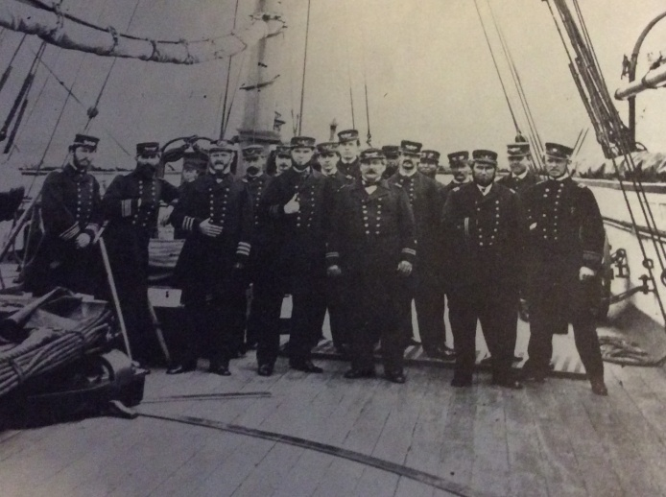

**CIVIL WAR JOURNAL of Franco M Sperrazzo Summer Edition June 2019**

**May 14th MEETING, ALLAN R. MAY, “Organized Crime in America/The Mayfield Road Mob”. Accompanied by Wife Connie, Author/Historian May chronicled Crime in America as it evolved from it’s European origins. Mr. May bounced back and forth though a timeline of criminal activity that has spread today through many cultures and ethnic backgrounds. His main focus was the Italian/Sicilian Mayfield Road Mob whose genesis grew following WW11. From the early 1st quarter of the 20th Century we were reminded of the Alphonse Capone vs George Moran feud and the mythical bootleg busting Elliott Ness whose final years were spent in Cleveland. Not enough mention of Charles “Lucky” Luciano, the modern mob architect until Q & A inquires. Or the influence of Danny Greene, on the long shore men scene and Alex Shonder Burns, who ruled in racketeering from Cleveland Hts. Some 58 members/guests were entertained and intrigued by the glamour of the infamous who thrived in the underground world syndicate of America.**

**SUMMER ONE DAY TRIP to OHIO STATE REFORMATORY, MANSFIELD, OHIO July 19th or 20th**

**The most recent entry our 22nd President Kenneth J. Godnavec, favors is an excursion on Interstate 71 South about 92 miles from our home base Pine Ridge Country Club. The Mansfield Reformatory Preservation Society, are the caretakers that conduct the tours of this historic place that according to OhioTraveler.com& groupon is rated 4.9 out of best 5. 2019, is the 25th of the Academy Award winning movie Shawshank Redemption was filmed there. The early prison was created in 1886 but earned a rebirth with the movie release in 1994. An usual aspect of the reformatory building is the showcasing of a combination of Victorian Gothic, Queen Ann & Richardsonian Romanesque Architecture. This blend of style was inspired from the Ancient Romans. Witness the tunnel innocent inmate Andy Dufresne, escaped from during the later stage of this outstanding movie. News publication Huffington Post, states this is one of the top 6 most haunted places in America. If we go on Friday July 19, we can experience of more extensive behind-the-scenes tour. Or we can stay with our usual Saturday July 20 date! This will be determined base on your feedback/response as to which day! President Kenny, has a surprisingly good an reasonable eatery in nearby Ashland, Ohio. OHIO STATE REFORMATORY: Is located on 100 Reformatory Road, Mansfield, OH 44905. Close to US Route 30 in Richland County. Daily open hours: 11am to 4pm. Phone: 419.522.2644. Cost may be $20. per person based on the number in our group. A separate flyer with final details & contact numbers will be sent out.**

**MENTOR PUBLIC LIBRARY, MAIN CAMPUS, 8215 Mentor Avenue, Mentor, OH 44060. Phone: 440.255.8811. *Leaders & Legacies of the Civil War, Wednesday June 12 noon until 1pm, Garfield Room. Subject: In Honor of the Civil Rights Movement March under Martin Luther King Jr.* Learn about events such as The Civil War, Slavery, the date June 19th. Also key figures like Rosa Parks, and early pioneers of the Civil Rights story. Presenters are JAGNHS Rangers /Volunteers. RSVP Required. Call (440) 255- 8811, or reserve on-line.**

**D-DAY 75th ANNIVERSARY, CONNEAUT, OHIO: From June 6, 1944 to this past week 2019 we witnessed many ceremonial tributes. On the 3rd weekend of August 15, 16 & 17 this year’s event will be a 3 day extravaganza on the beaches of Conneaut and this marks the 20th re-enactment there. This is the largest recreation of the one the most important moments in the history in the world. My wife Cyndy and this writer will go for our 3rd time. It is well worth your time to experience an overwhelming encampment of living history like you may have never scene located in our backyard. Visit:** [**www.ddayohio.us**](http://www.ddayohio.us) **to learn all the details.**

**BASEBALL HERITAGE MUSEUM/LEAGUE PARK, JUNE 6th, 2019. In cooperation with the Cleveland Indians, United States Navy over 130+ WW11 Veterans were honored with their families present and bestowed with the Bob Feller Honor of Valor Award for their tremendous contributions for our freedom and independence to protect our country & American citizens.**

**JAMES A. GARFIELD NATIONAL HISTORIC SITE CIVIL WAR MUSIC FESTIVAL: *Saturday, July 6, 11 a.m. to 4 p.m.* - Enjoy the site’s first-ever Civil War Concert Series, free of charge, with era-appropriate music of several bands and performers. Learn about the role of music in the Union and Confederate armies as you enjoy beautiful music and educational presentations on the lawn behind the Garfield home. *The home will be open for tours all day as well!***