THE COURIER
Northeast Ohio Civil War Round Table
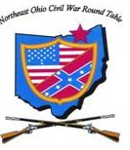

Tuesday September 10, 2019 Meeting #189
Canteen: 6:00 pm Dinner: 6:45 pm Program: 7:45 pm
Pine Ridge Country Club
30601 Ridge Road, Wickliffe, Ohio
Program: Stonewall Jackson at 2nd Manassas
Speaker: Henry P. Elliot
Reservations Required * Guests Welcome
e-mail: francomichael2414@yahoo.com or phone (440) 567-2414

From the President
On behalf of the Founding Fathers, The Executive Committee and myself, we welcome all members of the Northeast Ohio Civil War Round Table back to our fall 2019 speakers series. As always, we encourage all members to reach out and invite a friend or family member to join us in what we think is a very special group. I look forward to seeing everyone this Sept. 10 for our fall kickoff lecture.
- Kenny Godnavec

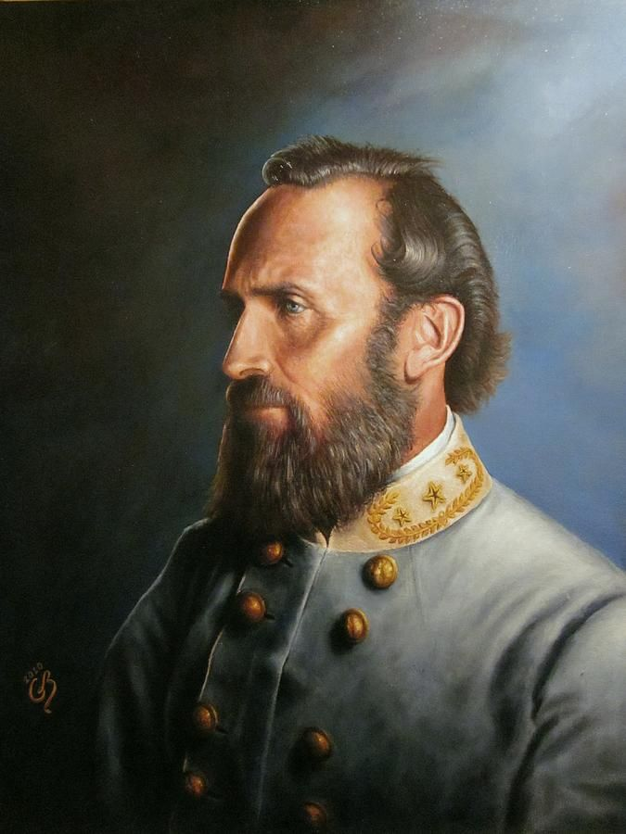
Stonewall Jackson at 2nd Manassas
In August 1862, Stonewall Jackson led 24,000 Confederate troops on a fifty mile march around John Pope’s Army of Virginia. Considered one of the boldest maneuvers of its kind during the Civil War, Jackson’s movement transformed the military picture in central Virginia – causing the Federals to abandon their strong defensive position along the Rappahannock River, allowing the Confederates to seize the initiative, and setting the stage for Southern victory. Although often remembered only for the legendary plunder that resulted with the capture of the Federal supply base at Manassas Junction, Jackson’s march was, in fact, the watershed moment of the entire Second Manassas campaign.
Henry P. Elliott
Henry P. Elliott is a historian at Manassas National Battlefield Park, where he has worked since 2007. During his twenty-year career with the National Park Service, he has also worked at Fredericksburg and Spotsylvania National Military Park and the Chalmette Battlefield, a unit of Jean Lafitte National Historical Park and Preserve. He is the author of the feature article on First Manassas in Blue & Gray Magazine and is currently writing a regimental history on the 4th South Carolina Volunteers. He resides in Jeffersonton, Virginia.
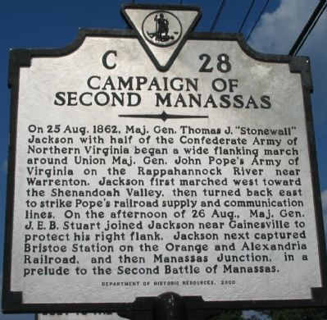

The Amazing Story of Chang and Eng, An Aside to the Civil War
By Paul Siedel
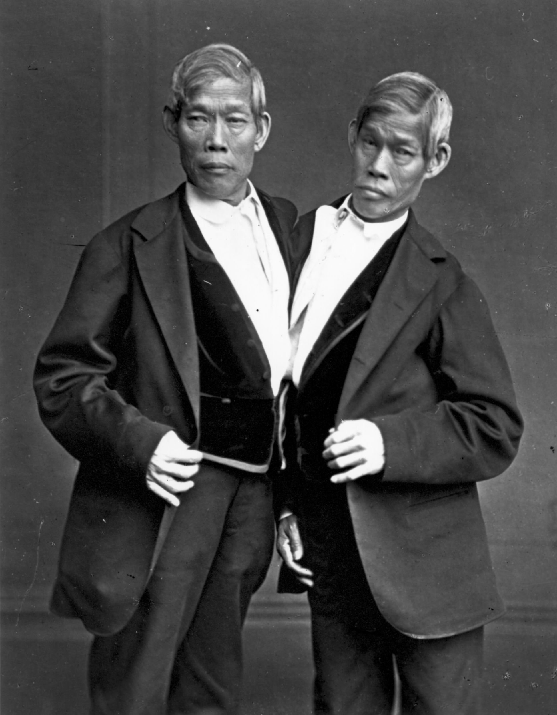
Sometimes it is by sheer happenstance or just by chance that one learns some of the most amazing things not just about the Civil War but about life in general. That happened to me recently when I picked up a book in front of a local bookstore entitled “Inseparable” the story of Chang and Eng. The story at first didn’t hold my interest but as I moved along it began to fascinate me.
It is the story of a pair of Siamese twins born in 1811 and how they were taken from The Kingdom of Siam and exhibited throughout the U.S. and Europe during the years before the Civil War. They were discovered and taken from their mother in Siam by way of India to escape a Cholera epidemic. Their mother freely gave permission for them to leave as she knew they would probably die if they stayed in Southeast Asia at that time.
During the next several decades they traveled around and were exhibited in all parts of the U.S. and Europe. They were joined at the side of their stomachs and in 2019 could have probably been separated but they both shared the same liver and separation back then was impossible. After a dispute with their manager P.T. Barnum they decided to travel through the U.S. themselves. In doing so they covered much of the South and New England and became very wealthy eventually owning and managing a small circus of their own. Later in life they decided to settle down and eventually chose Mt. Airy, North Carolina as their place of residence.
On October 12, 1839 they filed a petition to become U.S. citizens and the request was granted in 1840. They continued to live on their farm in North Carolina adding acres and purchasing several slaves to help them run the large cotton and tobacco plantation that eventually took shape. In 1843 the two Siamese twins married two local sisters and eventually had a total of fifteen children.
By 1860 Chang and Eng had become wealthy North Carolina planters and devoted secessionists. Since the 1840s their life had taken on a decidedly southern character and it was to the South that they devoted their resources, loyalty and manpower so as slaveholding landed gentry they sided steadfastly with the Confederacy. As the war progressed and their children came of age several of the young men enlisted in the Confederate Cavalry.
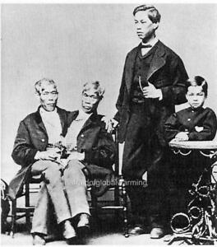
The twins had taken Bunker for their last name after becoming citizens and it was in 1863 that eighteen year old Christopher Bunker, son of Chang, joined the Confederate Cavalry to defend the Shenandoah Valley against David Hunter. He was captured and sent to Camp Chase, Ohio. His brother, Stephen Bunker, son of Eng, was captured near Winchester, Va. During Stoneman’s raid into North Carolina in March of 1865 the Union Cavalry officer had heard of the famous Siamese twins and their families and orders were given to leave them alone.
The war ended shortly after that and life settled down to normal at the Bunker home. Then in 1873 they decided to take a trip to Europe and visit some of the prominent people they met on their first tour back in the 1830s. They were welcomed by such personages as Queen Victoria, Bismarck, Prince Napoleon in France and Leopold King of the Belgians. They were on their way home aboard the “Palmyra” when Chang had a slight stroke. They arrived in New York and went directly to their home in Mt. Airy. There they sat for many hours each day in their double seated chair gazing at the wonderful view of the Blue Ridge Mts. One night the family heard a scream come from the bedroom of the twins. Eng’s son rushed in and saw the ashen face of Chang. “Uncle Chang is dead” he said to his father. Eng’s replied “then it won’t be long as I am going also.” He was gone in 3 hours.
A funeral service was held and shortly afterwards a request was made by the Mutter Museum in Philadelphia for custody of the body. The family steadfastly refused for obvious reasons. They did however grant the Mutter Museum permission to exhibit the liver which was shared by the twins. Today one can see that on display at the Museum. The bodies of Chang and Eng were interred in the family plot at the Wilkesboro Cemetery in Wilkesboro North Carolina.
The story of Chang and Eng is one of the more unusual stories emanating from the Civil War era and is proof of the fact that whenever we think we know it all, some little known fact comes to the surface and creates another new story all over again.
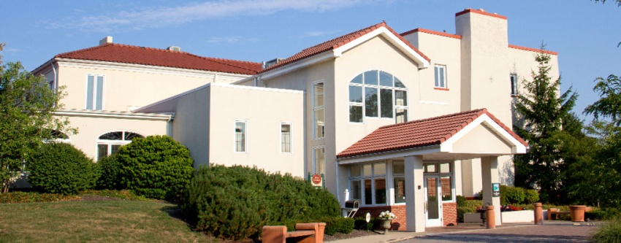
Pine Ridge Country Club
May 14th, 2019

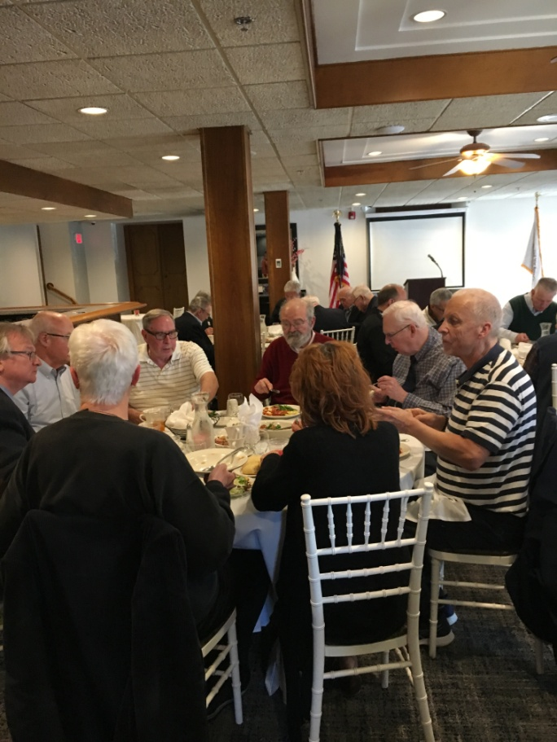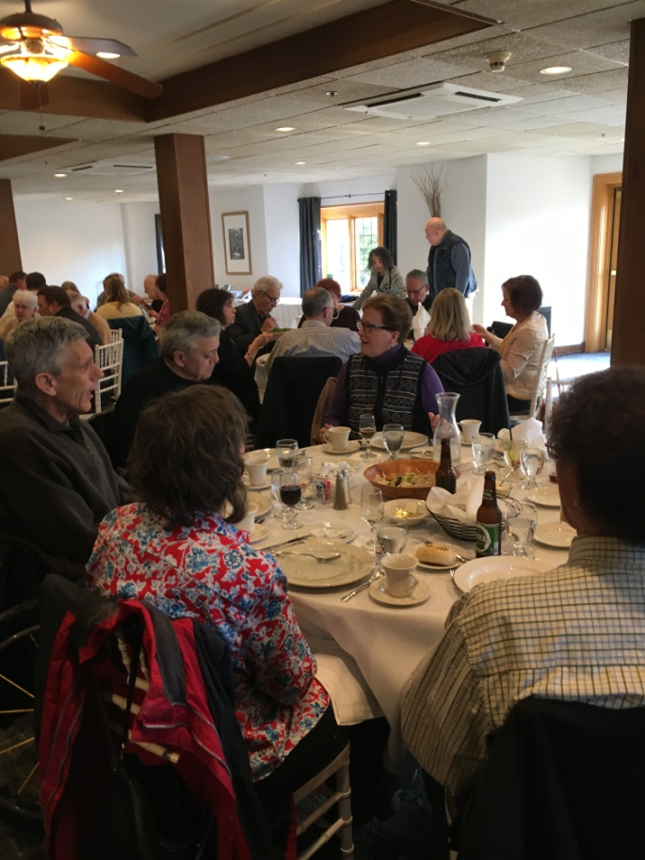

May’s dinner meeting had the year’s largest turnout to date as 60 people attended Allan May’s program, “Organized Crime in Cleveland”. Amazingly, one-third of the attendees were guests. The flag also had a big evening, winning the straw vote to continue flying at our meetings.
Around Town
July 5, 2019
James A. Garfield National Historic Site
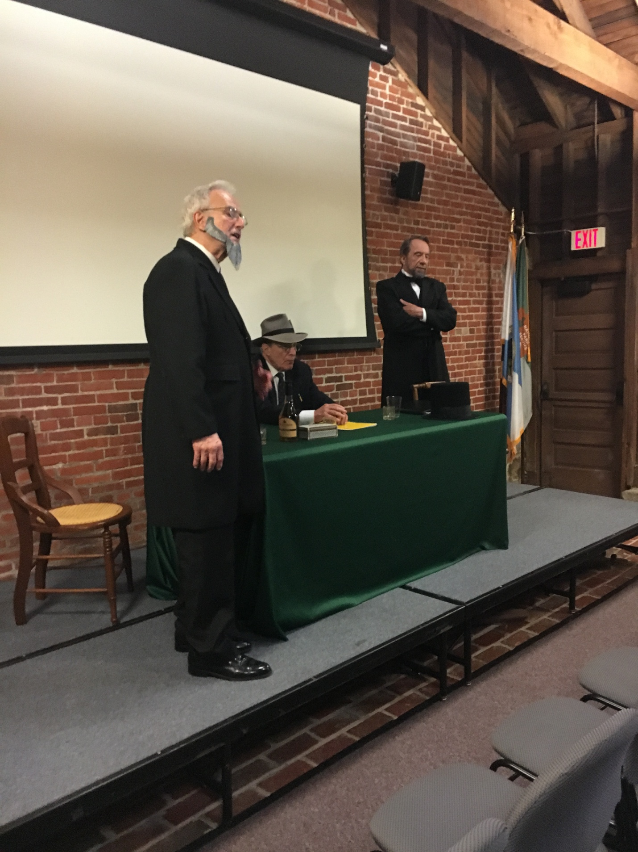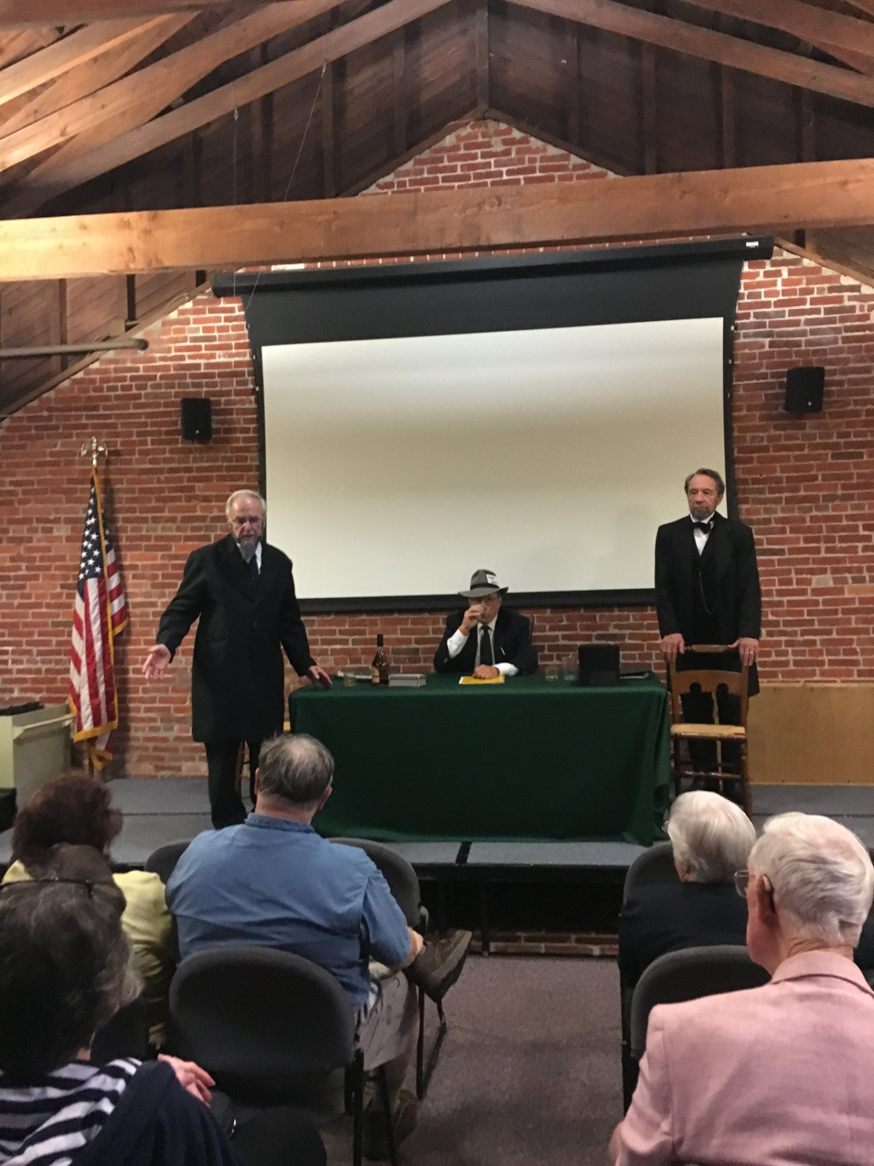
Lincoln’s Last Debate
Our 8th Annual NEOCWRT Symposium drew an appreciative audience of 40 people, with nearly half being non-members. Doors opened at 6pm with food and fellowship. Franco and his better-half, Cyndy, once again, provided us with a wonderful assortment of refreshments.
At 7pm, Site Manager Todd Arrington kicked-off the evening with a few appropriate opening remarks, and at 7:15 the curtains went up. In a nutshell, Jefferson Davis’ spirited defense of the South’s right to leave the Union, eloquent as it was, fell short in matching President Lincoln’s flawless logic to the contrary.
CIVIL WAR JOURNAL of Franco M. Sperrazzo September 10, 2019

Reflections of Henry P. Elliott: 5 members and 1 guest drove to Manassas National Military Park, VA in late September 2012 and had the privilege to meet Park Ranger/Volunteer Coordinator Henry “Hank” Elliott, who was assigned to our small battlefield tour group comprised of Arlan, son Alan Byrne, Tom Horvath Sr, Jonathan Sandy, Joe Abazzio this write rand (on the 2nd & 3rd day honorary member George Deutsch). We did not know back then young Hank, only facially bore a striking resemblance to Cleveland Indians player Mike Clevinger. The taller, younger Tribe hurler, was in the minor leagues when we met Ranger Elliott. There was a natural instant connection between our field leader and our members. Because we were so impressed with Hank, we invited him for a future visit to our NEOCWRT. This seemed like a good idea at the time. Little did we know after 7 years our mutual wish has come to fruition. Here is a vote of confidence you will enjoy engaging conversation and a thorough video PowerPoint program by Henry P. “Hank” Elliott.
Mentor Public Library, Leaders & Legacies of the Civil War, “The Battle of Antietam” @ Main Campus. This encore presentation explores the pros and cons surrounding the single bloodiest day in American History. Did either army really declare victory as Confederate General Robert E. Lee attempted to invade the North by deeply penetrating the Army of the Potomac. The noon program may last shortly past 1pm and is free of charge. They meet in the Garfield room. Several James A. Garfield Rangers and volunteers perform the monthly programs. You may bring your snack and beverage. Location is: 8215 Mentor Ave, Mentor, OH 44060 Phone: 440.255.8811. Mentor Library requests your RSVP to secure your seat.
Fall One Day Field Trip to Mansfield, OH. We intend to explore the confines of the Mansfield Reformatory. Hello NEOCWRT Members, Family & Friends. Our rescheduled adventurous excursion to MANSFIELD REFORMATORY/PRISON will occur on a Saturday in October. Once the new date is confirmed we will remind everyone again about the 11-11:15am arrival so we can start the tour by 11:30am. We can obtain Groupon 2 for 1 discount coupons in the $10. or less per person range. The hired guide included tour is only an additional $5.00 each. The guided exploration is strictly indoors or you may hike the grounds. Rain will not be a hinderance should it occur. As noted previously we added KINGWOOD GARDEN CENTER and have been informed we can go inside the mansion and enjoy the beautiful grounds both for the modest $5.00 fee per person. We are informed to arrive by 4-4:15pm. The WAR of 1812 BLOCKHOUSE across the road from KINGWOOD is easy to find and free to view in just minutes. We can achieve a more accurate people interested count by answering any questions or concerns you may have about the Mansfield Reformatory experience at our September 10th Fall kickoff meeting when our enthusiastic audience is treated by our special keynote speaker, Henry P. Elliott, from Manassas Military Park.
Sunshine wishes on the state of health for several members and their family: If you are so incline, we are asking for to help in conveying updated information on members you may have on the medical condition of any of our members or their immediate family. Thank you for your cooperation on this relevant request!
Hope your Summer 2019 has been eventful, meaningful and safe. Hope to see everyone on the 2nd Tuesday
Franco, Program Events Coordinator

