THE COURIER
Northeast Ohio Civil War Round Table
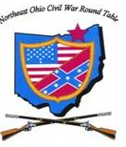
Tuesday November 12, 2019 Meeting #191
Canteen: 6:00 pm Dinner: 6:45 pm Program: 7:45 pm
Pine Ridge Country Club
30601 Ridge Road, Wickliffe, Ohio
Program: Deconstructing the Gettysburg Address
Speaker: Todd Arrington
Reservations Required * Guests Welcome
e-mail: francomichael2414@yahoo.com or phone (440) 567-2414

2019 NEOCWRT Officers
Founders: Bob Baucher, Norton London, Joseph Tirpak, Frank Yannucci
President: Kenny Godnavec Vice President: Tom Horvath, Jr.
Secretary: Scott Hagara Treasurer: George Maier Courier Editor: David Lintern
Sergeant-At-Arms: Steve Abbey, Bill Wilson Event Coordinators: Franco
Website Coordinator: Tom Horvath, Sr. 2019 Program Chairman: Tom Horvath, Jr.
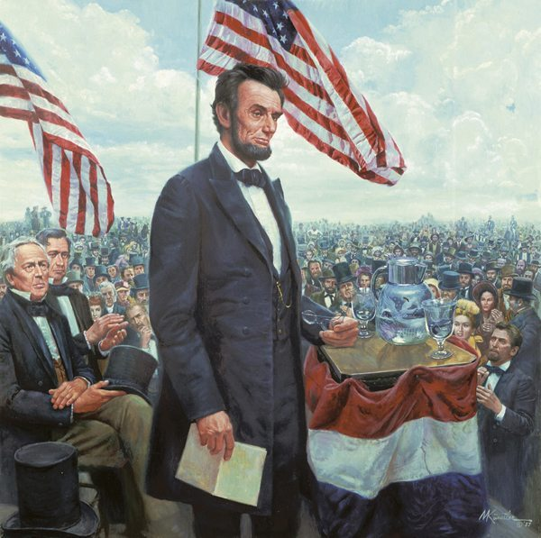
"Four score and seven years ago..." Thus begins one of the most famous speeches in human history, delivered by President Abraham Lincoln at Gettysburg on November 19, 1863. But what does the Gettysburg Address really mean? What was Lincoln trying to say and accomplish with these "few appropriate remarks"? This presentation will feature a line-by-line deconstruction and examination of the Gettysburg Address.

Todd Arrington, Ph.D.

Todd Arrington is the Site Manager of James A. Garfield National Historic Site in Mentor, Ohio, where he is responsible for all aspects of the National Park Service’s operation of the site. This includes interpretation, special events, partnerships, maintenance, budget, planning, and more. As a career National Park Service historian and park ranger, he has also worked at Homestead National Monument of America in Nebraska and Gettysburg National Military Park & Eisenhower National Historic Site, both in Pennsylvania. He is a veteran of the United States Army and holds a Ph.D. in history from the University of Nebraska-Lincoln (2012).

Todd has been published many times on subjects related to the American Civil War, the early Republican Party, the Reconstruction era, and America’s westward expansion. His essay “Industry and Economy during the Civil War” was published in The Civil War Remembered, the National Park Service’s official handbook commemorating the 150th anniversary of the Civil War. He writes for the popular history blogs We’re History and Emerging Civil War, and his book ‘The Triumphs of Liberty and Law’: The Presidential Election of 1880 will be published in 2020 by the University Press of Kansas. In discussing relevant history and National Park Service news and events, he has spoken at dozens of academic conferences and appeared on PBS, C-SPAN, numerous television and radio news programs, Radio Free Europe, and National Public Radio. He appeared in the PBS American Experience documentary Murder of a President about James A. Garfield. The film aired nationally in early 2016.

Todd has taught history and humanities courses at several northeast Ohio colleges, including Lake Erie College, John Carroll University, Lorain County Community College, and Lakeland Community College. He is a member of the Organization of American Historians and the Northeast Ohio Civil War Round Table.

CIVIL WAR JOURNAL of Franco M Sperrazzo November 12, 2019

OCTOBER 8th MEETING, “The Andrews Raid” by Tom Horvath and Tom Jr: Our distinguished father/son duo explored the exploits of a smaller band of Union raiders that intercepted a Confederate supply train in this 2.0 version of Tom Sr’s previous PowerPoint presentation. Their revised edition also profiled the 22 renegade participants in great detail by explaining the aftermath of what happened to these men. Most of whom met their demise. This intriguing subject came to life by the outstanding photos that help their audience understand the purpose of Andrews Raid.

REFLECTING on ROBERT R. BAUCHER: Will attempt to condense the emotions I have been experiencing on the loss of one of our co-Founder who will be missed. NEOCWRT club historian and our good friend, Big Bob, along with relocated Founder Rob Bayless, were instrumental in drawing up our CWRT club constitution. My first meeting with Bob occurred in January 1998 after being informed by my wife Cyndy their was a Civil War class being offered and Lakeland Community College. It was being held for the January/February months for 6 weeks in the Visitor Auditorium @ James A. Garfield NHS. The class oddly enough was titled CIVIL WAR JOURNAL. I wanted to remain but the class had reached capacity at 36 maximum quota. Oddly enough Mr. Baucher, co-facilitator found me convincing and allowed me to plead my case to Joseph “JET” Tirpak, who also approved. The rest of the story is truly history. We built an almost 22 year relationship by sharing time together on club 3 day Fall Field Trips. We were members of Society For American Baseball Research Organization. As our friendship grew we attended membership programs & volunteered at Jacobs Field. Bob also shared a special love for MLB Baseball & our Cleveland Indians. We even collaborated on a 2004 visual hands on program on Vintage Baseball wearing authentic uniforms. My friend and mentor was a stand up guy and true mench. Whether you agreed with him on current events, sports, history, politics or life experiences he was a terrific storyteller who told you his beliefs expressing his feelings about where you stood in his mind.

ONE DAY. JOURNEY to MANSFIELD REFORMATORY: Our team of 10 embarked on the historic prison on October 5th. The Mansfield Preservation Society, has done a remarkable job with this Victorian; Richardson Romanesque; Queen Anne Castle, saving it from being demolished following the success of renowned Academy Award winning movie “Shawshank Redemption” in 1994. The 1 hour 20-30 minute private tour exceeded our expectations. This palace originally housed inmates that were slated for reformation but that eventually changed. A must see trip should you have an interest. The CITY GRILLE is a typical Small Town USA sports pub with good food & hospitality. Located in the heart of the city in a rustic historic building. We completed our day at nearby KINGWOOD CENTER GARDENS. The 47 acre MANSION and beautiful garden grounds was the home of the Charles Kelly King family, that occupied the mansion in 1912. He was an entrepreneur man employed by Ohio Brass Company. He eventually ascended to the presidency & CEO. This estate will open a new visitor center in Summer 2020. Thanks to President Kenneth, First Lady Cheri, Son Trevor, Friend Nathan, Craig Niederriter, Wife Sarah, Daughter Anna, my Wife Cyndy, and the ghost of Errol Savage, for joining me on the tour.

MENTOR LIBRARY COVER to COVER, LEADERS & LEGACIES of the CIVIL WAR: NOVEMBER 13th held at MAIN CAMPUS on MENTOR AVENUE in the Garfield Room. 12 Noon - 1pm. This month an encore presentation of the “BATTLE of FRANKLIN”. Union & Confederate troops clash in Tennessee leading to a Confederate military disaster. Programs are produced by James A. Garfield Park Rangers, Historians & Volunteers. Bring your snacks & beverage to this FREE monthly series. RSVP 440.255.8811 to reserve you seat.

EXECUTIVE COMMITTEE MEETING TUESDAY OCTOBER 22nd: We convened with additional members present at Willoughby Hills Cracker Barrel. Among several topics was the idea of a year 2020 revisitation of a club legacy project. Theodore J. Karle and Jonathan Sandy, are leading the charge to return to a local Northeast Ohio Cemetery for the purpose of honoring our CIVIL WAR VETERANS. President Godnavec #22 is on board with the proposal in some form. Personally, I was grateful for my motion to have several members we noticed the past few years suffering with various medical conditions hampering them from attending regularly. They are being elevated to NEOCWRT HONORARY STATUS commencing year 2020. Our friends and members will continue to be afforded all privileges of full active membership and be welcomed to be with us whenever they possibly can attend. They include the following people: Arlin Byrne; Hudson Fowler 111; Jack Hattendorf; Major William Koekert; Terry Reynolds; John Michael Sears & Co-Founder Frank Yannucci. There may be more about this mentioned in the future.

HALE FARM & VILLAGE HOLIDAY EVENTS: The living historic rural home of Western Reserve Historical Society in lovely Cuyahoga Valley National Park is about to invoke their annual Holiday events. The indoor/outdoor farm plantation will host the following special programs soon: Thanksgiving with Abraham Lincoln November 16th; Holiday Market on the Farm December 6th; Holiday Lantern Evening Tours on multiple dates/times with reservations required. Location is: 2686 Oak Hill Road, Bath, OH. For more information: 330.666.3711. visit www.halefarm.org.

Hope to see everyone November 12th for Dr. Todd Arrington, PH. D, “Deconstructing the Gettysburg Address”.

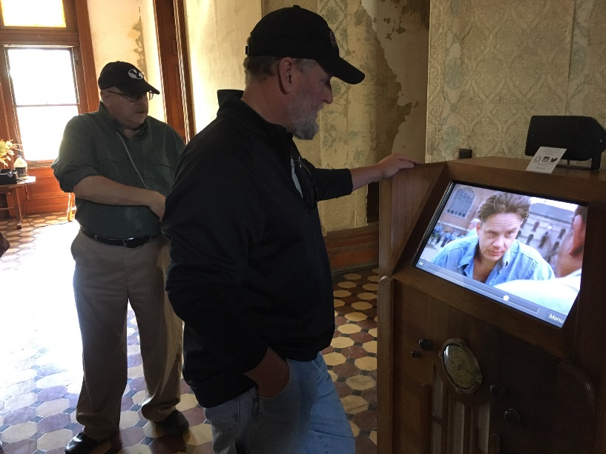
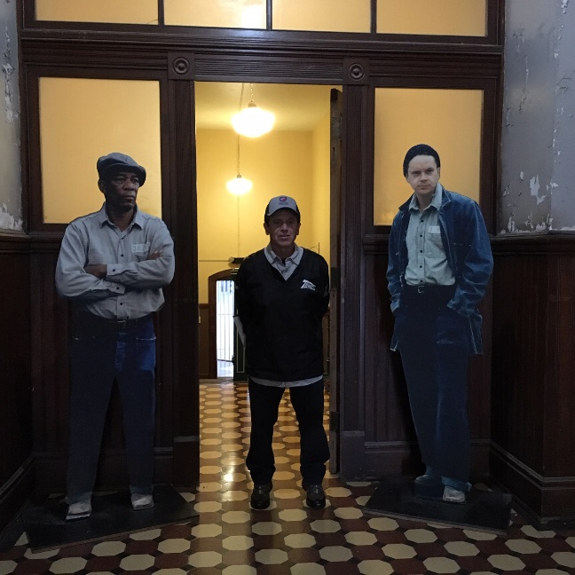

Mansfield Reformatory Field Trip

October 5, 2019

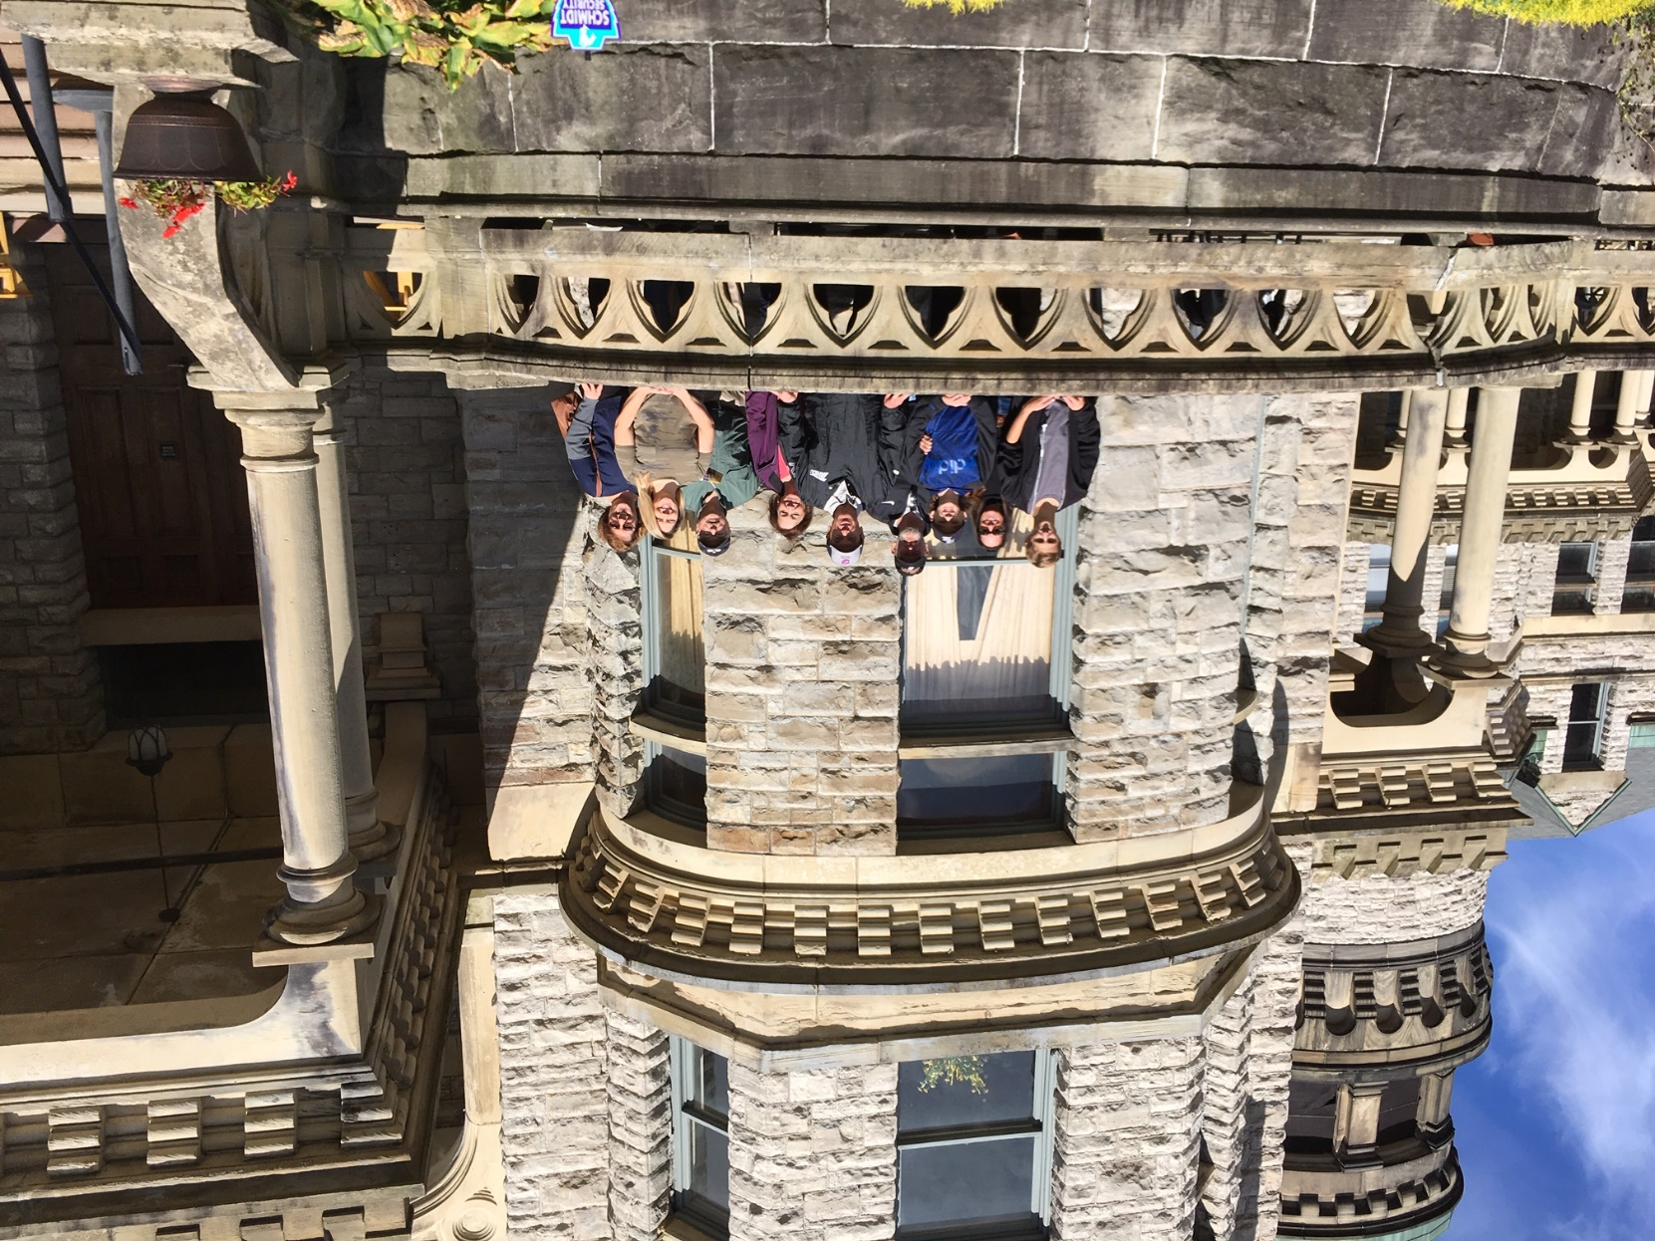

Recruiting in the Vanished Village of Newburgh
By Paul Siedel
As the Civil War recedes farther into history many of the once prominent landmarks of that time have become inconsequential or obscure having been absorbed by much larger cities or have become moribund and abandoned. Such was the fate of the once prominent village of Newburgh in Cuyahoga County. Today one can locate the old village on the map where Broadway Ave., Warner Rd., Turney Rd., Miles Rd., and E. 93 St. come together. The village was founded in 1799 with grist mills founded on the falls at Mill Creek. Later a stage road, today’s Broadway was cut through the area and quarrying and milling became the dominant economic forces sustaining the village. Many Irish immigrants came into the area with the building of the Ohio and Erie Canal. Later the Cleveland & Pittsburgh Railroad (now The Pennsylvania Railroad) came through and made it much easier to ship goods out of the area.
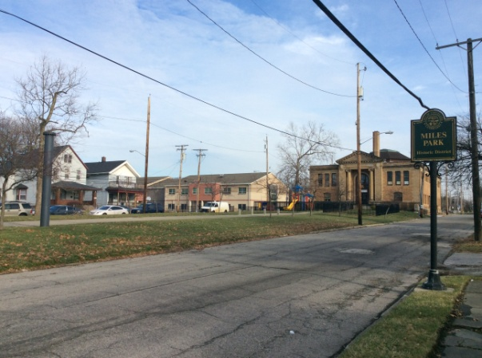
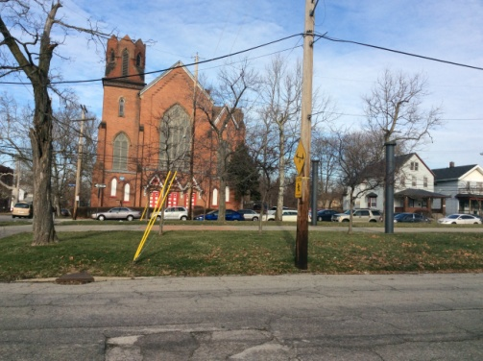
The village at one time was actually larger than Cleveland whose development was stymied by the mosquitoes which plagued the area. Newburgh was on higher ground and therefore escaped the large amounts of standing water. The water however is what eventually made Cleveland the County seat with easy access to Lake Erie and shipping on the Ohio and Erie Canals. Thus began the demise of the village of Newburgh. Much of Newburgh Township was taken in by the City of Cleveland in wave after wave of annexation just after the Civil War. The village center itself was annexed in 1893 and today is the area around E. 93 and Broadway. The old village green however is still very much visible and today is partly occupied by Miles Park Elementary School. The remainder today is a grassy area bounded by E. 91 St, E. 93 St. and Miles Park Ave. One can clearly see the center of the old village still visible today.
During the Civil War Newburgh was a bustling industrial village just to the south of Cleveland and was the location of a large recruiting station located on the village green. Recruiters were sent out from the various training camps located along Woodland Ave. between E 55 and Ontario St. According to the Encyclopedia of Cleveland History, men flocked into Newburgh and Cleveland to sign up and be taken to the training camps in Cleveland. As the Civil War progressed the Mills of Newburgh turned out steel rails from the factories located along Mill Creek and owned by such early entrepreneurs as Henry Chisholm, David and John Jones and others. After the War many southern soldiers came north to work in the mills of Newburgh having realized there was nothing left for them to earn a living in the devastated south. They seemed to blend well with the folks already there and one may imagine the old vets sitting around and listening to tales of what they did at Gettysburg, Spotsylvania, or Chickamauga. Names of vets such as Warner, Breck, Corlett, Jones, and Chandler who are today listed in the Soldiers and Sailors Monument were all residents of Old Newburgh.
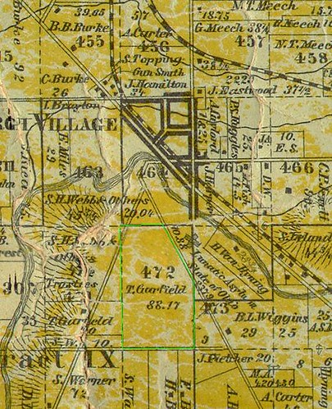
Today the old village of Newburgh is almost forgotten except for the suburb of Newburgh Hts. which occupies some of the old township. The old heavy industrial mills have closed and the last of them, the Worsted Mills, burned in a gigantic fire in the 1990s. Today the old village has been totally swallowed up by the growth of Cleveland and the old township has been given over to Cuyahoga Hts. There is, however, evidence of renewed growth. New housing has been built on the site of the old asylum on Turney Rd., and Cleveland Metro Parks has started a new reservation at the falls of Mill Creek. The Newburgh area has much potential and someday it may be realized giving new life to the once prominent village which did much to fuel the Union’s effort in the Civil War.
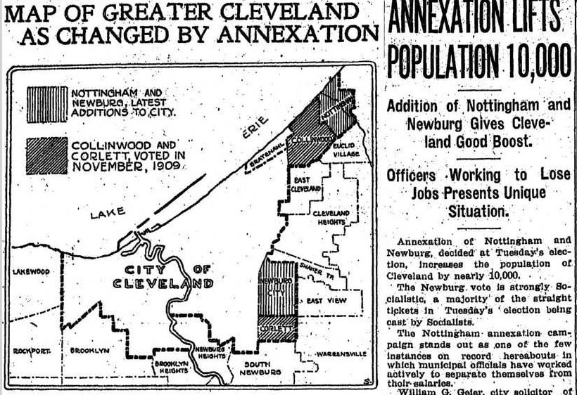
A Newburgh Family Story

On a cold January night in 1829, four young children slept as their mother sat sewing by the fireside. Their father was not home at the time. He was 15 miles away looking for land to buy in Orange Township.
The youngest child, suffering from an illness, got out of his bed and asked his mother if he could climb up on her lap. She smiled down at him and said, “If you give me a kiss you can.” Doing so, he quickly fell asleep in her arms. Tragically, within minutes, he was gone. Baby James Garfield was just two years old.
When the three older children woke in the morning, they found their mother sitting by the dying embers of the fire, holding their deceased baby brother. Eliza had not moved the entire night. Her husband was sent for, and he was soon at her side.
The family soon left Newburgh for their new farm and cabin in Orange. In 1831, Eliza gave birth to a new son. He was named for his late brother, but given a different middle name - Abram, after his father. The deceased James had been named for Eliza’s father, James Ballou.
With the loss of the middle child, there was a significant age gap between young James and his older siblings. Spoiled and pampered like a family pet, James detested farm chores in favor of his studies. Learning was his passion. As the years passed, his family and farming community watched in awe as he ascended from their world to the White House.
James A. Garfield returned to Newburgh often to visit his many Garfield relatives. His father’s youngest brother, Thomas, was a large land owner (see #472 in the above map) and a leading member in the community. Born 30 years to the day before his famous nephew, the two celebrated their last birthdays together in 1880 with a family gathering at Uncle Thomas’ home. Their ages were 79 and 49.
Tragically, both would die the following year, James from an assassin’s bullet, and Uncle Thomas from a horrific buggy/train accident in Warrensville. Both the shooting and the accident happened just ten days apart.

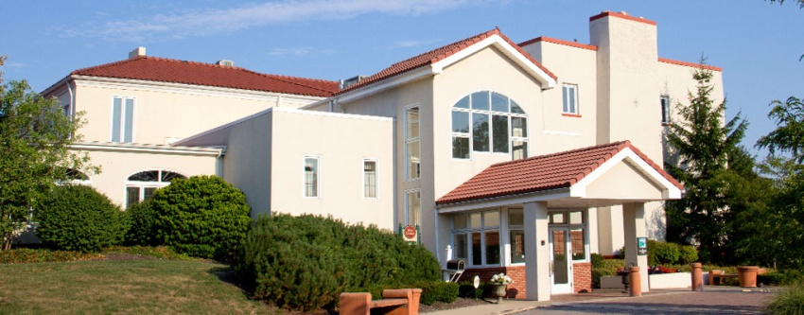
Pine Ridge Country Club
October 8, 2019

October’s dinner meeting had 29 members and one guest in attendance for Tom and Tom Jr. Horvath’s program, “Andrew’s Raid.” The talk had a refreshing, bouncy flair to it as the two speakers took turns telling the story. Founder Joe added to the evening with a tribute to our special fellow member and WWII veteran, Bill Koeckert.

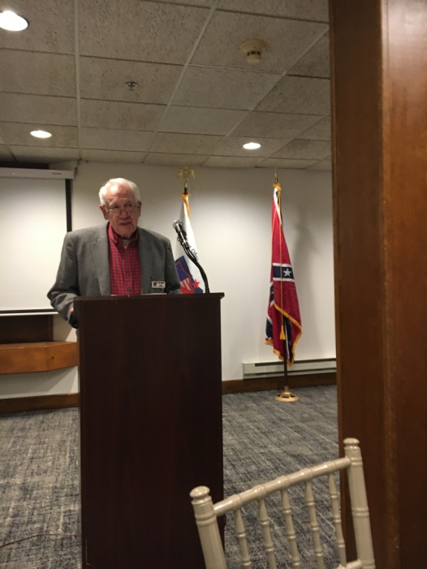
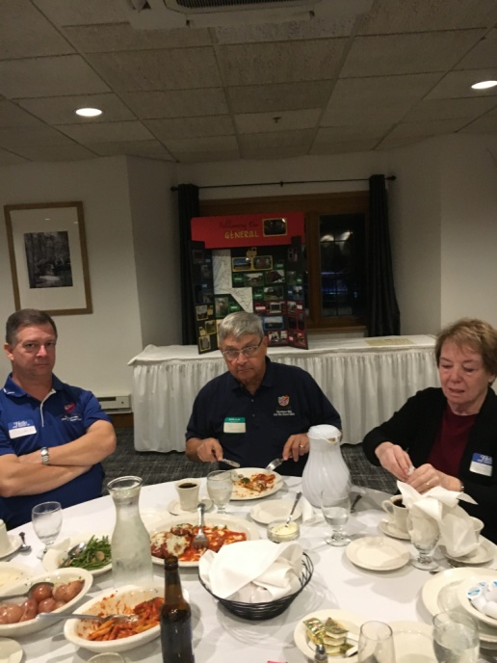

Excellent Food, Excellent Program

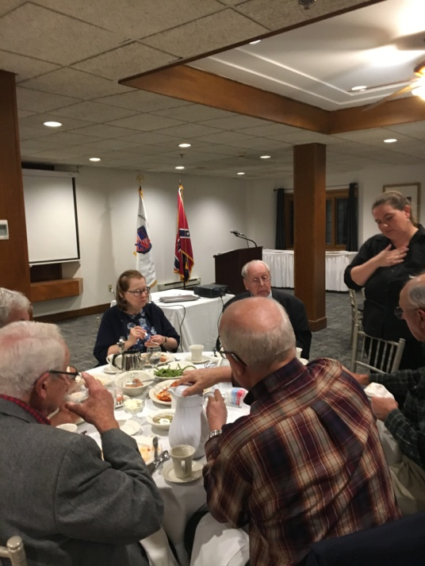
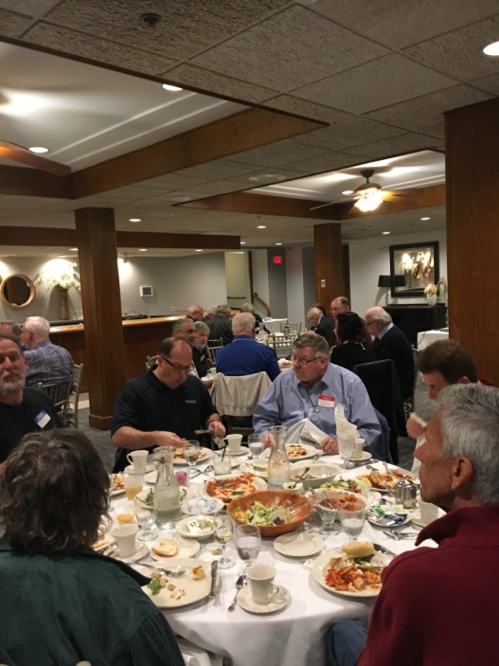

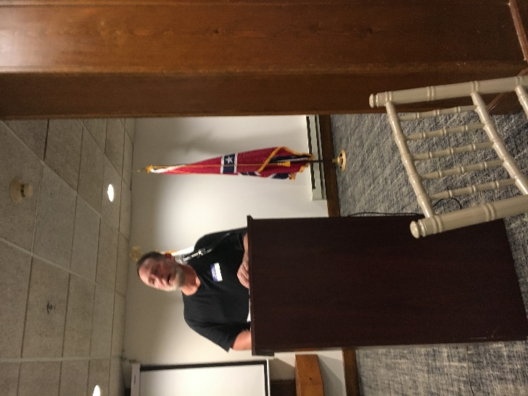
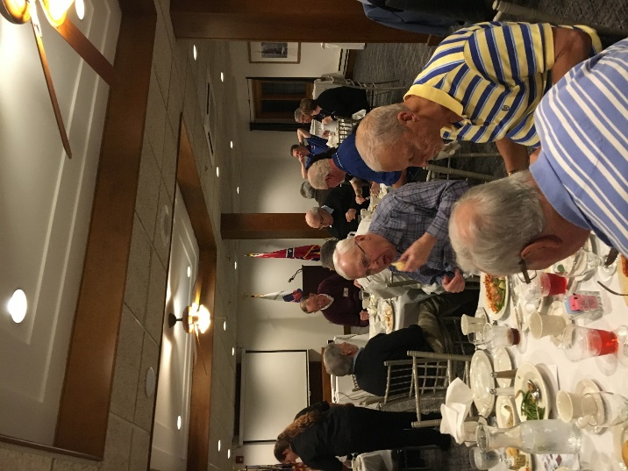

AROUND TOWN
John, Bill, Joe, Tom Jr. and Tom at Madison Country Club
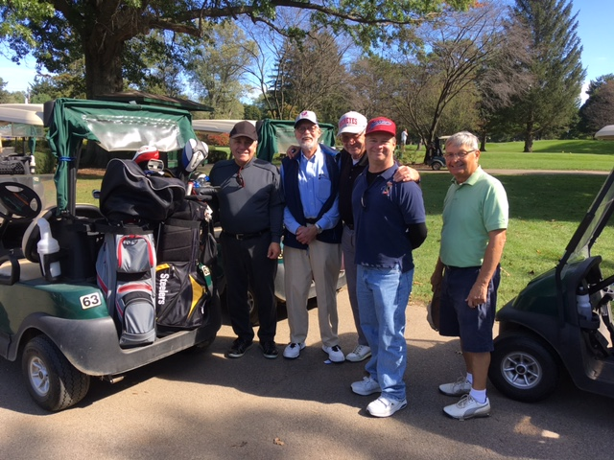

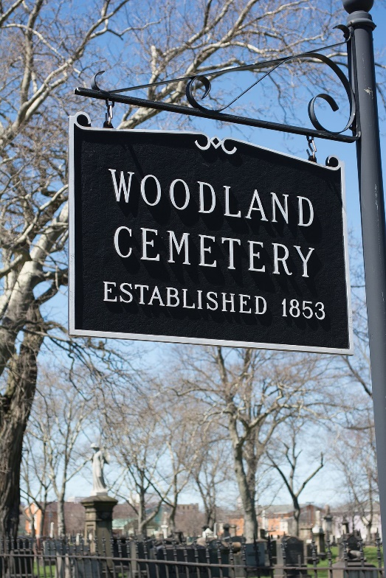
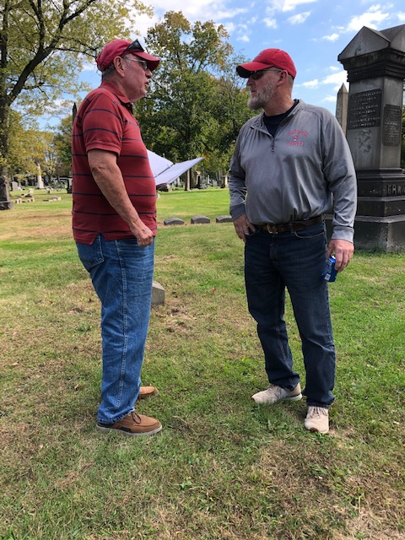
Paul and Kenny at Woodland Cemetery

