THE COURIER
Northeast Ohio Civil War Round Table
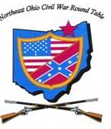
Tuesday March 12, 2019 Meeting #186
Canteen: 6:00 pm Dinner: 6:45 pm Program: 7:45 pm
Pine Ridge Country Club
30601 Ridge Road, Wickliffe, Ohio
Program: “Letters from the Front”
Speakers: Dan McGill & Debbie Weinkamer
Reservations Required * Guests Welcome
e-mail: francomichael2414@yahoo.com or phone (440) 567-2414

2019 NEOCWRT Officers & Committees
Founders: Bob Baucher, Norton London, Joseph Tirpak, Frank Yannucci
President: Kenny Godnavec Vice President: Tom Horvath, Jr.
Secretary: Scott Hagara Treasurer: George Maier Courier Editor: David Lintern
Sergeant-At-Arms: Steve Abbey, Bill Wilson Event Coordinator: Franco
Membership Coordinators: David Lintern, Franco Website: Tom Horvath Sr.
Pay Your Dues at the Door! $55 Individual $75 Couple
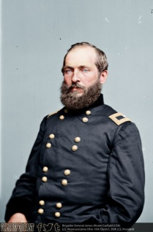
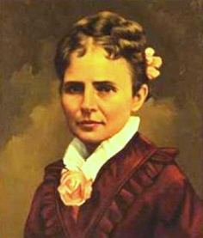
Letters from the Front
Gen. James A. Garfield – Dan McGill
Lucretia Garfield – Debbie Weinkamer

Dan and Debbie will be doing a first-person reading of excerpted letters between General Garfield, who is in the field, and wife Lucretia, who is at home. Garfield entered the army as a Lt. Colonel in August 1861, serving in the Western Theater. He served as a brigade commander in the Army of the Ohio under Gen. D.C. Buell, and Chief-of-Staff under Gen. William Rosecrans in the Army of the Cumberland. He left the army a Major General in December 1863 to take his seat in Congress.
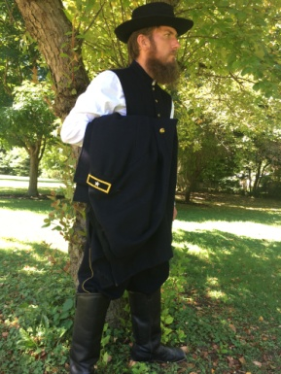
DAN McGILL is a resident of Mentor and is employed as a Seasonal Park Ranger at the James A. Garfield National Historic Site. Dan is a self-professed “history nerd”, and is currently studying for his Master’s degree at Kent State, concentrating in late 19th and early 20th Century American History. Before joining the Park Service, Dan volunteered as a docent at the Soldiers and Sailors Monument in Cleveland.
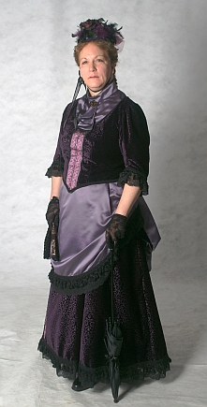
DEBBIE WEINKAMER has been involved with the Garfield family story since 1998 and has been portraying Lucretia Garfield since 2001. With an AA and a BS in Early Childhood Education, Debbie strives to make her presentations engaging, meaningful, and educational for all ages. She is the Lead Volunteer at the James A. Garfield National Historic Site, and a seasonal docent at the Garfield Memorial Cabin in Moreland Hills. Debbie is honored to be personal friends with the Cleveland-area descendants of President and Mrs. Garfield.

From The Editor
David Lintern
This month’s editorial is in reply to last month’s scholarly contribution from Ted. Although my response may read a bit critical and defensive, it is intended in a friendly, good-natured manner. I have the highest regard for Ted. He is a good friend, and I feel completely out of my league engaging him in debate.

“A PERSPECTIVE ON THE CONFEDERATE FLAG” DID NOT MISS THE POINT… IT COMPLETELY DISMISSED IT!

To review, my three talking points were…1) Sensitivity to the perspective of African-Americans, 2) Offering a remedy for the flag’s dilemma as a target, 3) Regard for our Union soldiers who died by the hundreds of thousands. As these points were not addressed, I will move on and summarize the crux of Ted’s points.
To begin, I can appreciate the reverence a number of our members have for the Confederate flag. Their perspective comes from a deep, longtime passion for Civil War history. The rest of us, as I read between the lines, are expected to just go along with flying the flag because we “unwittingly” don’t get the big picture. Grouped as “non-thinkers”, we need to brush up on the First Amendment, not be “intimidated” by outside forces, and stop being so darn “politically correct”. I’m sorry, but General McAuliffe expressed it best at Bastogne, “NUTS”!!
As for revisionists, I’m grateful to the scholars who have re-visited Civil War history, otherwise all thinking people would still believe the war was fought over states rights. I will say that I very much agree with Ted’s third stanza (except for the last sentence, in which case I’ll be happy to step up and do the explaining).
As for the last stanza, the Confederate flag does not stand humbly ignored at our dinner meetings. If it did, we would not be having this conversation. And it did not stand humbly at Appomattox. We all saw the painting, it got rolled up.
In closing, not all thinking people affirm our right to display our flag as we choose. Last year, Mentor Public Library politely nixed our idea of placing our rebel flag in their entry hall display cabinet with our collection of Civil War memorabilia. They did, however, allow the Union flag.
From The Vice-President
Tom Horvath, Jr.
Is It Time For A Change?

To weigh in on the matter of the Confederate Battle flag, which was well discussed from both points of view in the February Courier, I began to wonder about whether we should switch to the southern national flag instead of the battle flag. One of the missions of our club is to educate, and I believe in looking at both sides of an issue (and many of the gray areas in between). To show we consider the southern point of view, do we need to display the battle flag, or would not the National Flag do?
I dislike having to make a change based upon the opinions of people outside our organization, but given there are people in our country with disturbing agendas rallying around the battle flag, sometimes changes are necessary. Paul Siedel aptly pointed out when the southern national flag is displayed it is generally left alone and does not promote the negative emotions the battle flag does. Admittedly, this does not answer what to do with the battle flag if we make a change, but I am hoping that it does give us an option to show we are not forgetting the southern point of view.
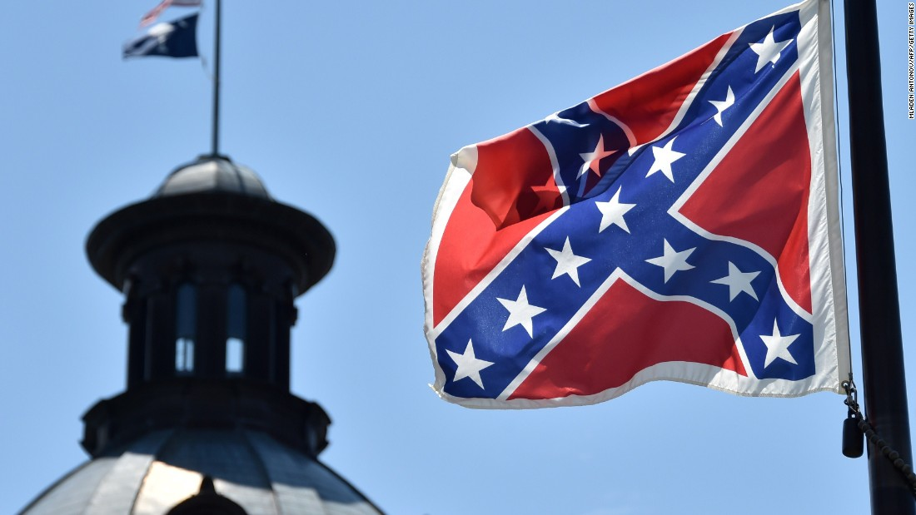
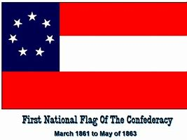

WATCH WHERE YOU POINT THAT CAMERA, PLEASE!
I would never want my picture taken at one of our dinner meetings without my knowledge. I would be horrified if my picture ended up on Facebook with the Confederate flag in the background.
Mary Lintern, Member
Book Review
By Todd Arrington

Dr. Arrington’s book review appeared in “The Civil War Monitor” shortly after the book’s release.
Grant, by Ron Chernow. New York: Penguin Press, 2017. 1,074 pp. $40 (hardcover).

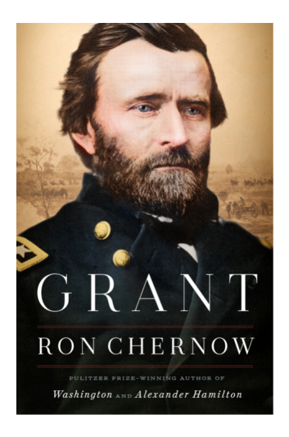
The standard interpretation of Ulysses S. Grant’s life has usually been: an undistinguished West Point and antebellum army career ended by alcohol abuse, followed by a meteoric rise in rank and responsibility during the Civil War, followed by a failed presidency riddled by scandal and then a triumphant memoir written while he was dying. While some historians have perpetuated the idea of Grant as an unfeeling “butcher” during the Civil War—especially as Union forces slugged it out against Robert E. Lee’s Confederates during the war’s final year—most have revered Grant’s military prowess and given him his due for his central role in ending the war. Until recently, though, few have taken a serious look at Grant’s postwar life and presidency and offered a reassessment that increases Grant’s standing as a civilian leader. Ron Chernow’s massive new biography, Grant, does just this and is a far more valuable contribution to understanding Grant after the war than during it.

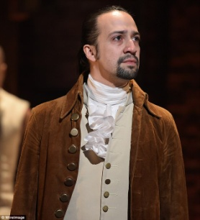
Though his background is in journalism rather than history, Chernow has gained a reputation for well-written, lengthy biographies of important figures in American history. You probably know him for his Pulitzer Prize-winning biography of George Washington, or his renowned Alexander Hamilton, the book that served as the basis for Lin-Manuel Miranda’s popular musical Hamilton. Grant will certainly add to his standing as one of the nation’s most prominent (and verbose) contemporary biographers.
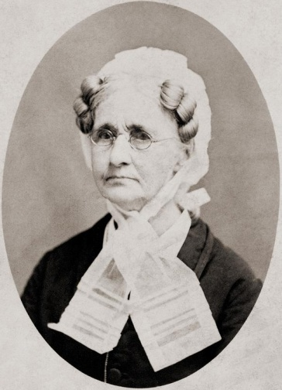
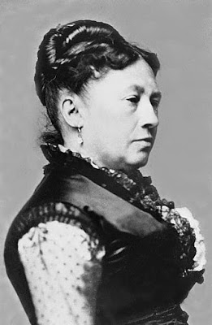
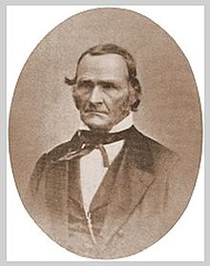
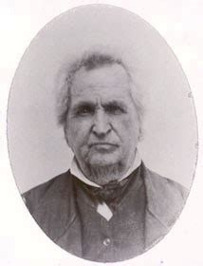
Chernow shows us a young Ulysses S. Grant whose mother, Hannah, was detached and unaffectionate and whose father, Jesse, loomed large as his son’s fame and influence grew during the Civil War and then as president. The father was always quick to try to capitalize on his son’s name, both for himself and for relatives and friends. One thing young Ulysses did get from his father—and that Chernow masterfully examines in the book—was a dislike for the institution of slavery. Grant possessed an inherent sense of fairness that made him view slavery as an immoral institution, and this feeling stayed with him through the war and his presidency. It also made his life difficult when he married Julia Dent, whose father, Frederick Dent, was a staunch Democrat and slave owner. While Julia proved a devoted wife and wonderful partner for Grant, his relations with his father-in-law were never overly cordial.

As anyone with even a passing knowledge of Grant’s life knows, alcohol played a large and detrimental role in it. Chernow seems to have made it his mission to once and for all answer the questions about Grant’s history with liquor. There is no doubt that alcohol abuse was the reason Grant left the army in 1854. In Chernow’s telling, Grant was an alcoholic, and he knew it and acknowledged it to others. He overcame the addiction through willpower and with the help of his wife, who ensured her husband avoided temptation when she was with him.

During the Civil War years, when he was away from Julia for extended periods, he tasked members of his military staff, particularly his friend John Rawlins, with keeping him sober. Chernow writes incessantly about Grant’s relationship with alcohol for well over half of the book. However, by the end of the Civil War and certainly by the time Grant was president, he had conquered his addiction and lived the rest of his life with few minor relapses. With this, alcohol—practically a main character in much of the book—is barely mentioned again.

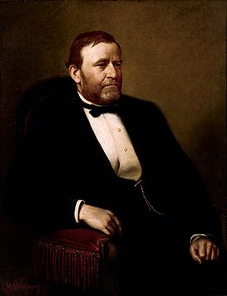
The real value of Chernow’s Grant comes when the author turns his sharp research and writing skills toward Grant’s two terms (1869-77) as the eighteenth President of the United States. While traditionally viewed as a failure as president, Chernow (along with other recent historians) convincingly argues that Grant was a far better chief executive than often thought. He was dedicated to ensuring the rights, freedoms, and safety of African Americans, and his administration vigorously pursued indictments against members of the Ku Klux Klan. That inherent sense of fairness, the lessons he learned during some of his own life’s lowest periods, and his experiences with black troops during the Civil War all combined to make Grant a dedicated ally to former slaves in the South. Chernow quotes Frederick Douglass as noting that, “To Grant more than any other man the Negro owes his enfranchisement… In the matter of the protection of the freedman from violence his moral courage surpassed that of his party.”

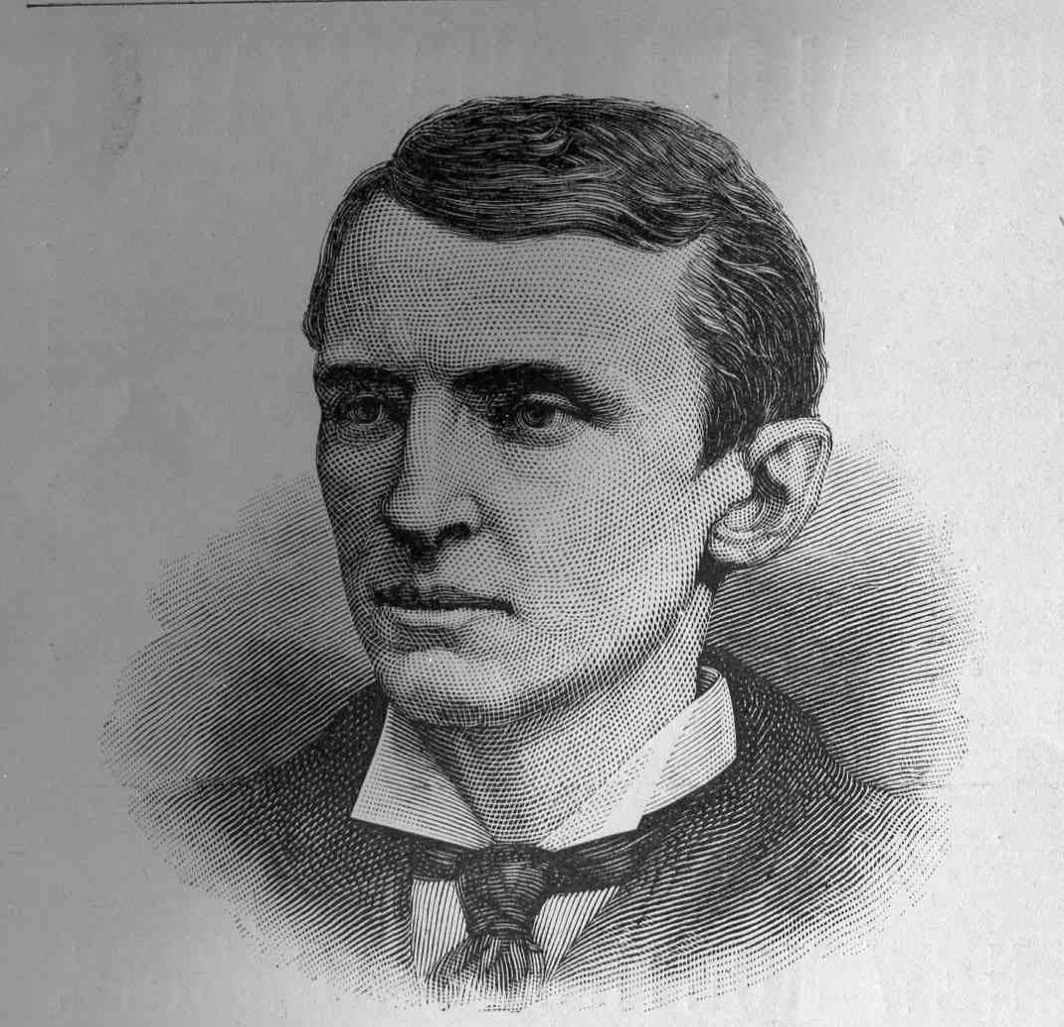
Chernow also shows the reader that U.S. Grant could be almost painfully naïve when judging people. As a friend he was loyal to a fault, even to many that no longer deserved his friendship or good graces. While we see that President Grant was personally honest and dedicated to running an efficient, ethical administration, his choices of close advisers and cabinet officers did not always serve him well. Many of the scandals that past historians have used to judge Grant’s presidency a failure—the “Whiskey Ring” and others—resulted from others taking advantage of their positions and their relationships with Grant, who was often slow to act when disciplining or firing a friend was required. After his presidency, his blind faith in young financier Ferdinand Ward, a family friend, cost him every dime he had.

While Chernow’s book is certainly not perfect—for example, he pays little attention to events in the West—Grant is definitely an accomplishment that belongs on the reading lists of those interested in the Civil War as well as students of American politics and the presidency. This book will be one that future scholars look at as they reassess Grant’s political career, and if his presidential ranking continues to rise, there is little question that Ron Chernow’s exhaustive research and accessible writing style will be at least part of the reason.
Book Review
By Bill Meissner

The Silk Roads - by Peter Frankopan

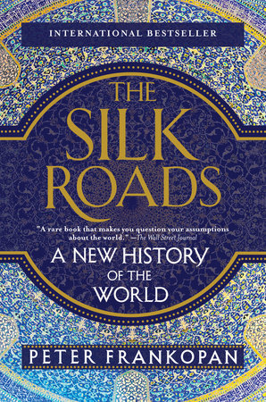
If you are like me almost all the history we studied in school was the history of western civilization. Perhaps your studies began with the Greeks or Romans progressing into Europe and finally to the Americas. I recently finished a book that follows history from the ancient Middle East using the caravan routes that began several millennia ago. Routes that carried goods from the Far East to the western Mediterranean and then north and south into Africa, Europe and areas north into what is now Russia.

The author makes a compelling argument that commerce, not politics, has driven progress and changes in human civilization. The book is an easy read, divided into twenty-six chapters between twenty and thirty pages each. It is fully researched with full documentation of sources and indexed.

Beginning more than six thousand years ago and continuing well into the twenty-first century, it includes the development of religions, ethnic identification, the rise of nationalism, changes of borders, and the emergence and falling of cultures over time. Because of its focus on the Middle East and the flow of events to and from this region, it is a very different way of looking at history.

Joe Tirpak’s son, Mark, loaned the book to me at Thanksgiving, and I finished it by Christmas.

Published by Vintage Books, a division of Penguin Random House LLC, New York, it is available at Barnes and Noble for $27.

DOAN’S CORNERS & THE UNDERGROUND RAILROAD
By Paul Seidel

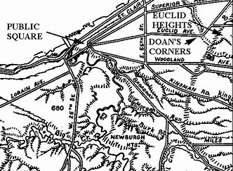
Not very long ago there came into my possession a copy of a map of Cuyahoga County dating from 1858 shortly before the Civil War. There were several things that struck me as I began to study this fascinating piece of history, one being the fact that most of the main arteries, including the railroads, were in place by that time, and that the names of the property holders throughout the County were on each parcel and very easy to read. The other fact of which I was not aware was that there were many small villages which once existed as separate entities but have since vanished into the mile after mile of urban sprawl which today has become greater Cleveland. Villages such as Albion, Newburgh, Dover Center and Brooklyn Center were once separate and distinct places each serving the surrounding farmland and the people who lived there. One such place was the village of Doan’s Corners which stood at the intersection of E 105 and Euclid Ave.
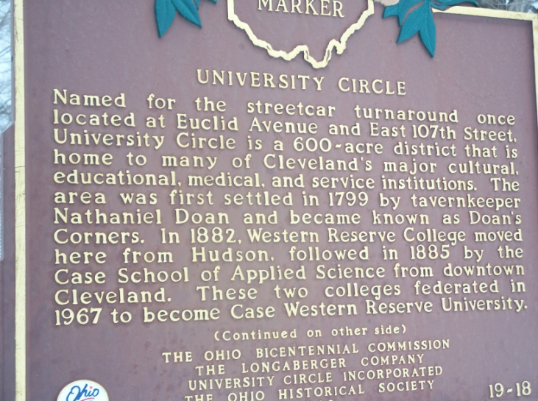
According to the Encyclopedia of Cleveland History the village of Doan’s Corners was located at the intersection of The Buffalo Road (Euclid Ave), Doan’s Road (E. 105) and Fairmont Road (E. 107). The entire line of unbroken residential and commercial buildings extended along Euclid Ave. from Mayfield Road west to Crawford Road and played a very important part in the area’s Underground Railroad movement. Many freedom seekers made their way here from other parts of the Western Reserve. From here they waited for nightfall and were either smuggled aboard a coach to Buffalo, where they made their way to Canada, or simply followed Doan’s Brook northward to the Lake where a prearranged meeting would take them by boat out of U.S. jurisdiction . Many of the families that founded and resided at Doan’s Corners, such as the Fords, Doans, Cozads and Bates were very much involved in the abolition movement and were instrumental in helping freedom seekers attain their ultimate goal of freedom in Canada.
Doan’s Corners takes its name from Nathanial Doan who decided to relocate his blacksmith shop from Superior Ave. in downtown Cleveland four miles west. Here he built a blacksmith shop and store. Stage coaches stopped here on their way to Erie and Buffalo, and the intersection became a bustling village of stores, churches, homes and a hotel. It was part of East Cleveland Township, but was ultimately annexed by Cleveland in 1872. Case and Adelbert Colleges were established and the village took on the atmosphere of a college town. By 1900 the expanding city had largely engulfed Doan’s Corners, and by the 1930s the village had become the home to several theaters, commercial blocks, hotels and homes, which brought thousands to the area.
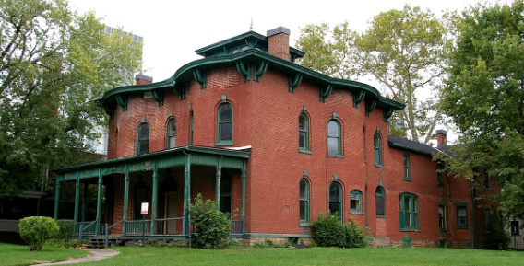
By this time, however, the old village had become completely engulfed by the giant to the west, and Doan’s Corners vanished as a separate entity forever. The area became known as Cleveland’s “second downtown” with its bustling nightlife and commercial activity. By 1970 Doan’s Corners was overcome by the epidemic of urban blight which overwhelmed the surrounding neighborhoods. By 1980 all of the old buildings had been razed and the area took on the appearance of an urban wasteland. The attached picture is of the Cozad-Bates house, the only remaining antebellum structure in the University Circle area.
Today, new life has come to Doan's Corners. The Cleveland Clinic Foundation, Case-Western Reserve University and an active neighborhood organization have reclaimed and breathed new life into the now vanished village along the old Buffalo Road. The old settlers would no doubt be proud of their village, which today has been replaced by a world class institution, putting Cleveland, once again, in the forefront of progress, this time in the medical industry, just as the first settlers who became involved in the social progress that was to set millions free.

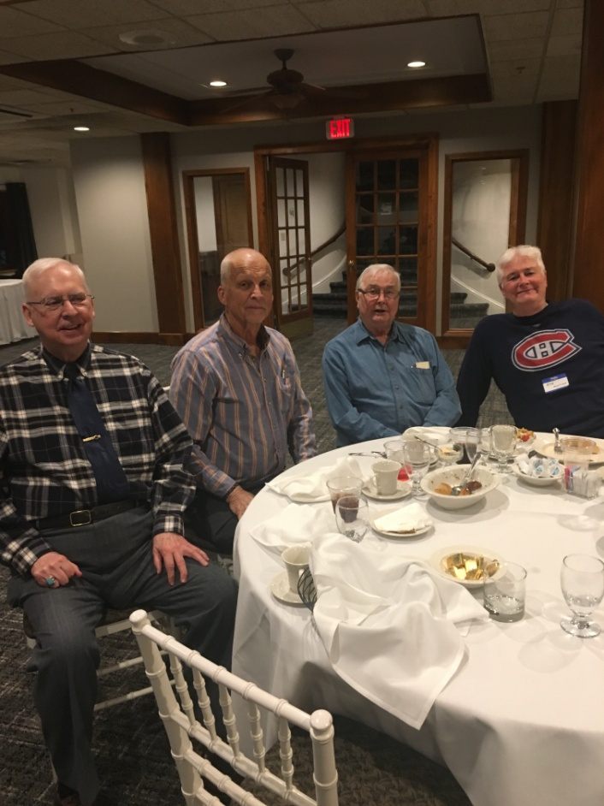
WELCOME TO OUR NEW MEMBERS!
Our club added a number of new members at the end of 2018, including these fine four gentlemen. Left to Right are Charles Stenger, Craig Stenger, Wayne Moster, and Bob Moster. The two sets of brothers are longtime members of the Cleveland Round Table, and regular attendees at Mentor Public Library’s Civil War talks. Please say hello to them and welcome them to the club.

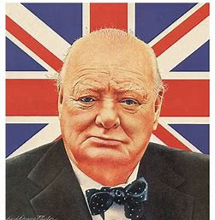
Good Comeback Mr. Churchill…

Parliament member: "Mr. Prime Minister, must you fall asleep while I'm speaking?"
Churchill: "No sir, it's purely voluntary."
Lady Astor: "Sir, if you were my husband, I'd put poison in your coffee."
Churchill: "Madam, if you were my wife, I'd drink it."

All articles appearing in the Courier do not necessarily state or represent an endorsement of the facts, conclusions, and opinions of the author(s) by the NEOCWRT or its membership.

