THE COURIER
Northeast Ohio Civil War Round Table
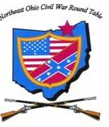
Tuesday January 14, 2020 Meeting #193
Canteen: 6:00 pm Dinner: 6:45 pm Program: 7:45 pm
Pine Ridge Country Club
30601 Ridge Road, Wickliffe, Ohio
“Boston Corbett”
by Paul Siedel
Reservations Required * Guests Welcome
e-mail: francomichael2414@yahoo.com or phone (440) 567-2414

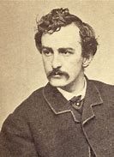
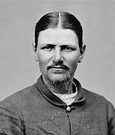
Paul Siedel presents
“Boston Corbett”
The Man Who Killed John Wilkes Booth
Paul Siedel

Anyone in this club who doesn’t know Paul Siedel is either a new member, or never attends our dinners. Paul is one of our club’s biggest “doers”, with countless contributions to the program committee, the Courier, and helping out with many of our field trips.

Paul lives in Ohio City. He joined the NEOCWRT in 2007, and despite the long drive, his attendance record at our dinners is among the highest in the club. Paul also belongs to the Cleveland CWRT and the Quincy Gilmore CWRT in Elyria. It would seem the man just can’t get enough Civil War history. In addition, he belongs to the Woodland Cemetery Foundation, and probably knows as much about the cemetery as anyone in the Cleveland area. Just ask him about the Civil War soldiers buried there.

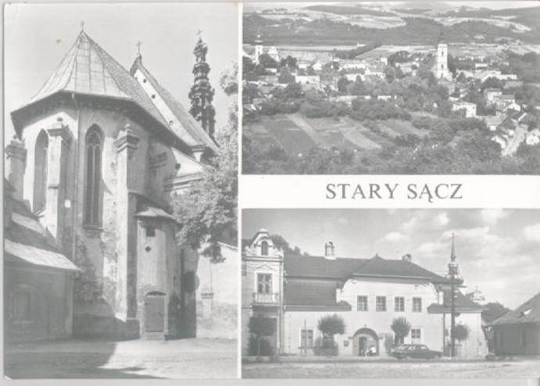
Paul is a 1968 graduate of Olmsted Falls High School, and a 1972 graduate of Akron University in Elementary Education. He began his career in 1972 as a third-grade teacher for Prince William County Schools. He then taught at Midview Local Schools in Grafton, Ohio from 1976-2002. From there he had a stint in Stary Sacz, Poland from 2003-2005 teaching “English Language Education”.

Paul gives talks all over NEO with an assortment of historical topics. His interest in Boston Corbett (I’m guessing) was fueled by his journey to the actual site where Booth met his demise. You won’t want to miss this program. We are in for a real treat.

The Mystery of the Assassin’s Skull
Whatever Happened to the Remains
of Lewis Thornton Powell?
By Paul Siedel

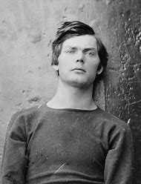
During the early 1990s The U.S. Supreme Court delivered a ruling that permitted Native American Tribes to reclaim the remains of their ancestors that had been commandeered by historians and archeologists over the years. It was during a search of these remains that archaeologist Stuart Speaker of the Smithsonian Institution’s Anthropology Department took up a box containing some long forgotten remains that he wished to catalogue. In among the Native American bones he found a skull that he at once identified as not being that of a Native American. The tag on the skull identified it as belonging to one Lewis Thornton Powell, one of the four conspirators hung on July 7, 1865 for planning and partaking in the assassination of President Lincoln. The Army Medical Museum identified it as exhibit number 2244. Several Lincoln experts were contacted. James O. Hall, Michael W. Kauffman and Betty J. Owensby viewed the skull. They compared the dental records with those in the National Archives and they did indeed match those of Lewis Thornton Powell. How did his skull become part of the Native American archives and where were the rest of his remains?
Lewis Thornton Powell was born in 1844 in Randolph County, Alabama. The family moved to Georgia and later to Live Oak Station, Florida. Lewis’s father, George, was a Baptist Minister and part-time farmer. The family owned several slaves which were the playmates of young Lewis during his early years. Powell was just 16 years old when he enlisted in the Hamilton Blues which would become Company I of the Second Florida Infantry. Young Lewis was shipped north and fought with the Army of Northern Virginia until being wounded and captured at Gettysburg. Young Powell, being only slightly wounded, became a doctor’s assistant and was taken to the U.S. hospital in Baltimore. There he met Margaret Branson and her sister Mary, both very dedicated southern sympathizers. They helped him walk away from the West Building of the U.S. General Hospital, and he immediately began looking for his old unit, eventually ending up in Warrenton, Virginia. It was here that he became acquainted with the Payne family of that area. Warrenton and the Fauquier County area was part of what is called “Mosby’s Confederacy” and it was to Mosby and his band of irregulars that Powell gravitated. He became one of Mosby’s most daring men, and it was while escorting a band of prisoners to Richmond that that he may have become involved with the Confederate Secret Service.
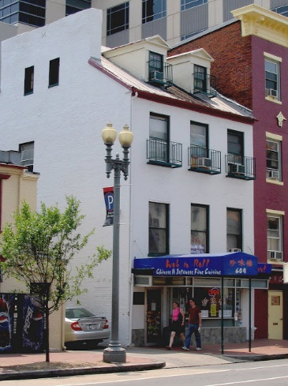
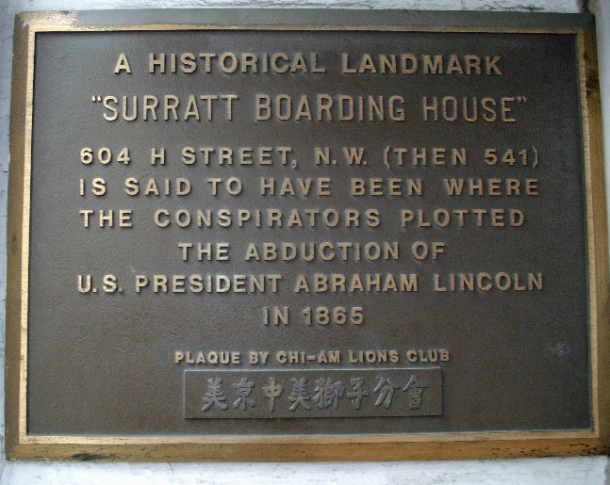
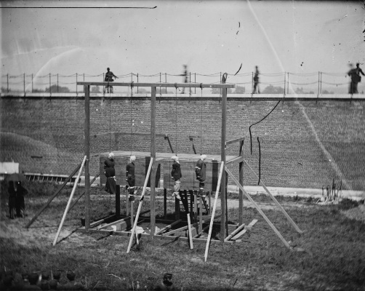
Powell came back from Richmond a changed man according to his comrades in Mosby’s band. He left Fauquier County in January of 1865, and this part of his life becomes very unclear. Some say he met with Judah Benjamin during his Richmond sojourn, some say he met Booth earlier in the war while attending a play in Richmond, and was attracted by the actor’s magnetic personality. There is no proof of any of this. However, he showed up in Baltimore again, and with the help of the Branson sisters began running messages into the dying Confederacy. He soon met John Surratt, a friend of John Wilkes Booth and a Confederate agent. Some say Powell went to New York and then on to Canada with Booth, but no one is really certain. In March 1865, he became part of the plot to kidnap the president and, this having failed, fell in with the assassination plan. He met with Booth and John Surratt at Mary Surratt’s boarding house in Washington, and on the night of April 14 made his way to the house of Secretary of State William Seward. Pretending to have a prescription for the injured Secretary, Powell made his way upstairs where he was confronted by Frederick Seward, the Secretary’s son. He pistol-whipped Fred and forced his way into Seward’s bedroom. Slashing violently at the Secretary, he wounded George Robinson, the male nurse, pushed Fanny Seward to the floor, and attacked Seward’s other son, Augustus Seward. He then ran from the house shouting “I’m mad, I’m mad”. Although the Secretary of State was gravely wounded, he would survive. Two days later Powell showed up at the boarding house of Mary Surratt just as she was being arrested by several U.S. Army officers. They took Paine, as he was calling himself, into custody, and it wasn’t long before the Seward’s butler identified him as the man who assaulted the five members of the Seward household on April 14th. The rest is history - the confinement aboard the “U.S.S. Montauk”, the trial, and his execution along with Mary Surratt, David Herold, and George Atzerodt. After the execution all four bodies were buried next to the gallows. Henry Wirz, the Commandant at Andersonville, was eventually buried next to them. In October 1865, the bodies were disinterred and buried in the floor of Warehouse Number 1 in the Arsenal complex. In 1869 Edwin Stanton eventually relented and allowed the bodies to be reclaimed by the respective families. All were reclaimed and taken to the various cemeteries, where they rest today. All that is except the remains of Lewis Thornton Powell. The family could not afford to come to Washington from Florida and the remains were buried in Washington D.C.’s Holmead’s Cemetery at 19th and T Streets. According to Betty Ownesby’s well-researched book, “Alias Payne,” that cemetery was eventually vacated and the remains were removed to Graceland Cemetery. Powell’s body was thus disinterred three times and it was sometime probably in January 1885 that the skull was detached and became anatomical specimen number 2244 at the Army Medical Museum. However, when the large wooden coffin was moved from Holmeads to Graceland Cemetery, it contained only a skull and a pair of broadcloth trousers, the same in which Powell had been buried. What happened to the rest of the remains is still a mystery.
In 1993 the skull was turned over to the members of the Powell family in Stuart, Florida. They buried the skull with all the dignity afforded a family member who had been lost but then returned. There the remains of Lewis Thornton Powell lie buried today along with members of the Powell family long since deceased.
Was Powell a member of the Confederate Secret Service? No one really knows and much has been speculated. There is no concrete proof that he knew Judah Benjamin or any other member of the Confederate government. What ultimately happened to his remains? Until someone discovers some long-lost papers in some long-lost location, the file on Lewis Thornton Powell still remains open.

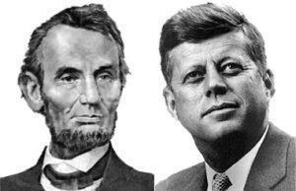

Do You Remember?
I know that many of you have seen or read some version of the following coincidences as they relate to Abraham Lincoln and John F. Kennedy. However, as I paused to reflect on the meaning of these coincidences I do remember vividly how I felt when I first received word of President Kennedy’s assassination. Perhaps these two former Presidents are linked by some generalional oddities too complex for us to fathom? Maybe there is a linkage between these two presidents?
If we could measure these coincidences on some type of “Richter Scale” I think they would be off the chart!
- Lincoln was elected President in 1860, Kennedy in 1960.
- Both were slain on a Friday, from behind, shot in the head, while in the presence of their wives.
- Both lost children through death while in the White House.
- Both were succeeded by Southern Democrats named Johnson.
- Andrew Johnson was born in 1808, Lyndon Johnson in 1908.
- John Wilkes Booth was born in 1839, Lee Harvey Oswald was born in 1939.
- Booth shot Lincoln in a theater and ran to a warehouse. Oswald shot Kennedy from a warehouse and ran to a theater.
- Lincoln’s secretary was named Kennedy. Kennedy’s secretary was named Lincoln.
- Both assassins were killed before they could be brought to trial.
Of this I am sure:
- Each of us old enough to remember that fateful day when Kennedy was slain can recall exactly where we were at that moment.
- Each of us can remember exactly what we were doing at that moment.
- Each of us can remember exactly how we felt as witnesses to this shocking historical event!
- Yes, it is etched in our minds forever!
Joe Tirpak, Founder
November 2009
Revisited Jan 2020

