THE COURIER
Northeast Ohio Civil War Round Table
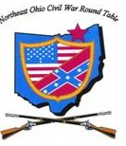
Tuesday February 11, 2020 Meeting #194
Canteen: 6:00 pm Dinner: 6:45 pm Program: 7:45 pm
Pine Ridge Country Club
30601 Ridge Road, Wickliffe, Ohio
Chancellorsville
by David Lintern
Reservations Required * Guests Welcome
e-mail: francomichael2414@yahoo.com or phone (440) 567-2414

2020 NEOCWRT Officers & Coordinators
Founders: Norton London, Joseph Tirpak, Frank Yannucci
President: Tom Horvath, Jr. Vice President: Scott Hagara
Secretary: Paul Siedel Treasurer: George Maier Courier Editor: David Lintern
Sergeant-At-Arms: Steve Abbey, Bill Wilson Event Coordinator: Franco
Audio/Visual Coordinator: Tom Horvath, Sr. Program Chairman: Scott Hagara
February’s Program
Chancellorsville
Lee’s Greatest Victory & Jackson’s Last Battle
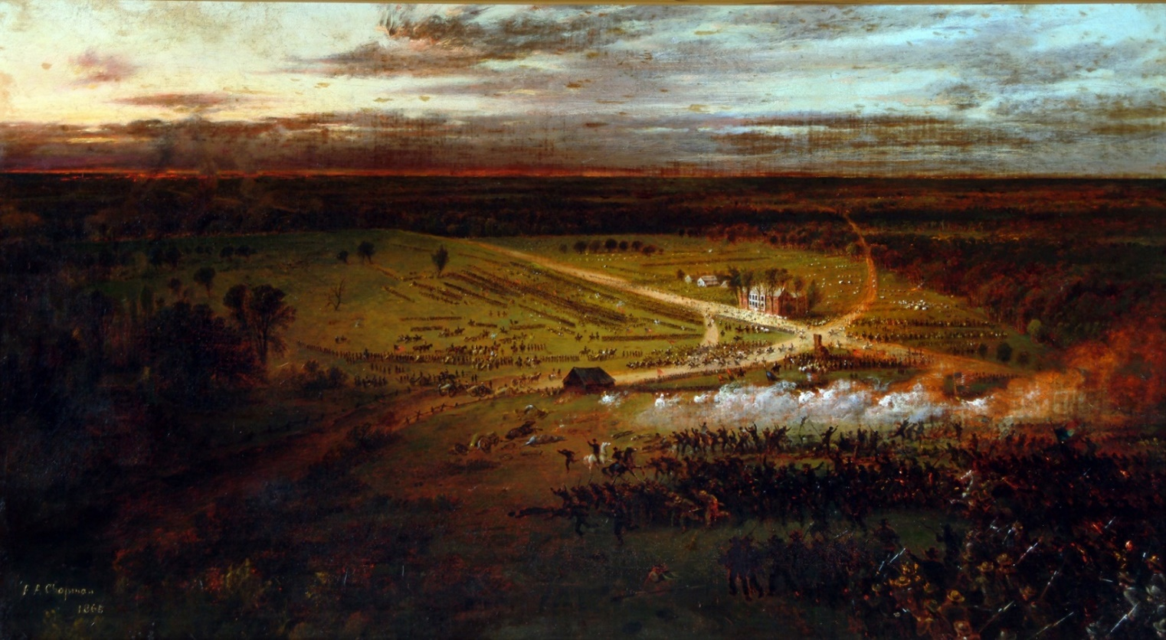
Presented by David Lintern

David is a life-long resident of Lake County, with past addresses in Madison, Concord, and Painesville. Today, he and his better half, Mary, live in Kirtland. He is a graduate of Riverside High School, Ohio U., and Case Western Reserve. David has been in banking and cost accounting since his early days, and is currently looking forward to retirement, whenever he gets around to it.
Why has he chosen Chancellorsville as his presentation? It’s his favorite battle.
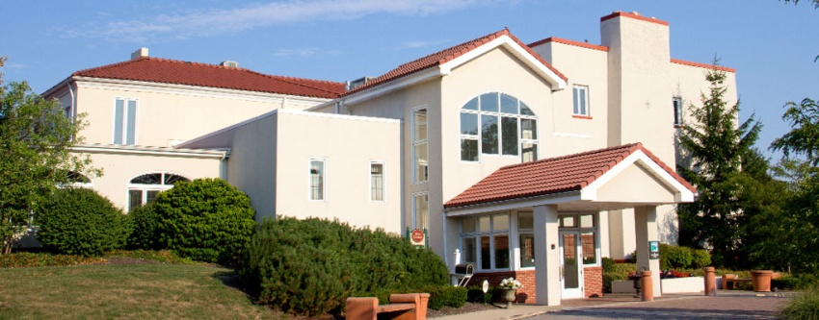

Pine Ridge Country Club
January 14, 2020
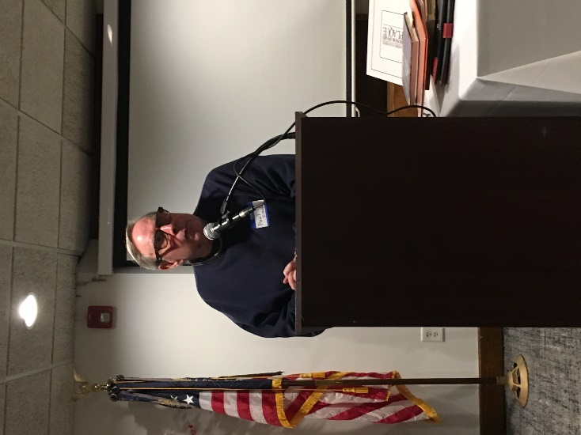

Thirty-one members and four guests attended January’s meeting to hear Paul Siedel’s presentation on the soldier who shot and killed John Wilkes Booth. Boston Corbett disobeyed orders when doing so, but was not convicted. As a result, he became a life-long celebrity. Eat your heart out, Jack Ruby.
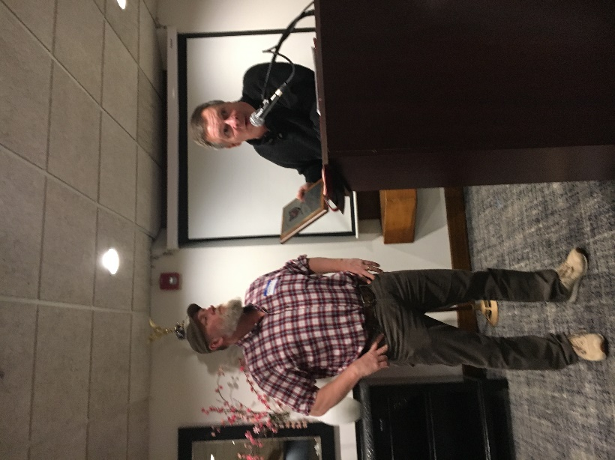
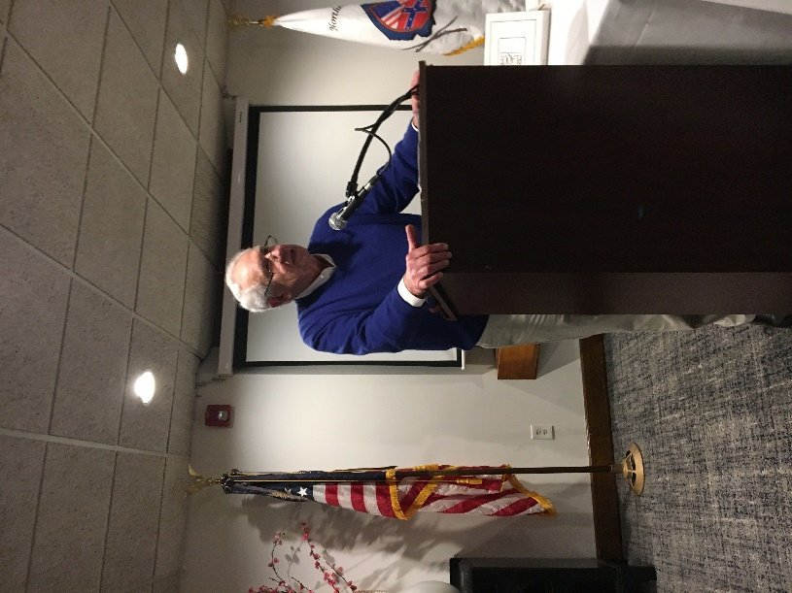

Kenny gets his plaque Joe addresses the club
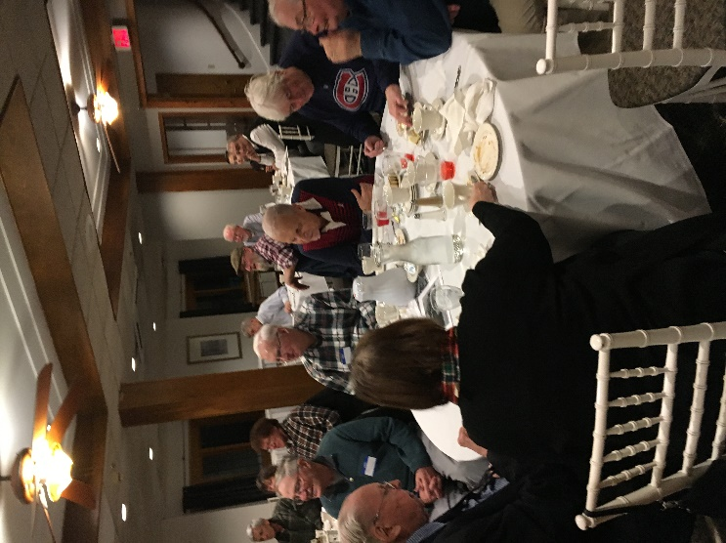
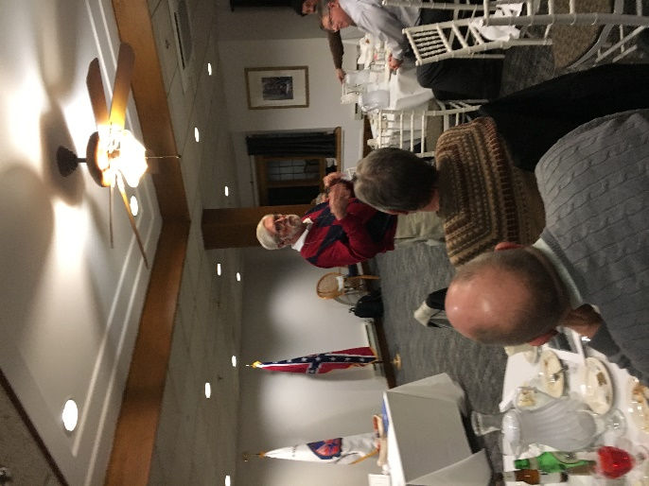

Bill gets a laugh Another good turnout

CIVIL WAR JOURNAL of Frank. M. Sperrazzo February 4, 2020
January 14th meeting Paul Seidel: Boston Corbett (actual name Thomas Corbett) was born in London, England in 1832. Member Paul covered the many stages of the enigmatic life of the man who disobeyed orders when he shot and killed John Wilkes Booth. Corbett was a hatter, private in a New York Regiment in the Union Army, street preacher, prisoner of war at Andersonville, dishonorably discharged soldier and insane asylum inmate. Corbett’s death and disappearance to this day is open to conjecture and remains a mystery. Paul Siedel showed his outstanding ability to research and prepare his power point presentation. His writing contributions to the Courier shows his value in sharing his extensive travels to numerous historic places in Civil War America.
NEOCWRT 2020 Membership Dues: We appreciate your 2020 membership fees during the first quarter of the new year. Good news – no price increase! Single membership is $55, and spousal/partner amount is $75. Send your check to Treasurer George Maier, 8695 Blue Heron Way, Mentor, OH 44060. If you write a check at the February meeting, please keep the amount separate from the dinner meeting cost. George, Bill Wilson or Steve Abby will be stationed at the entrance way and will gladly accept your payments.
NEOCWORT 2020 Administrative Officers & Coordinators:
23rd President- Tom Horvath Jr. Program Events Coordinator - Franco Sperrazzo
Vice President- Scott Hagara Book Raffle/ 50-50 Drawing - Bernard Taub
Secretary - Paul Siedel Flag Bearer - Troy Long
Treasurer - George Maier Founders - Norty London
Sergeants of Arms - Steve Abby - JET Tirpak
- Bill Meissner - Frank Yannucci
- William Wilson 2021 Program Chairman - Scott Hagara
Audio/ Video Techs/ Website 2021 Program Members - Tom Horvath Jr.
- Tom Horvath Sr. - Paul Siedel
-John Sandy - John Sandy
Membership Directors - Kenny Godnavec - Kenny Godnavec
-Rich Miklaucic - Franco
Sunshine Committee - Steve Abby
Memorial Honors Program- Ted Karle - Francisco Franco

Mentor Public Library: “Leader and Legacies of the Civil War” Main Campus: Program is Wednesday, February 12th from noon – 1:00pm, Garfield Room. Enjoy a timely encore presentation from 2013. This month will teach attendees more about the life tapestry and legacy of Abraham Lincoln. The program is produced by James A. Garfield NHS Park Rangers, historians and volunteers. RSVP to secure your seat to the free monthly event. Bring your beverage/ snack to the Mentor Avenue Library Branch. Phone: (440) 255-8811.
Spring One-Day Tour: Lake County Project Hope and Steel Mansion in Painesville, Ohio. Our confirmed date is Saturday, May 30th. Lunch during mid afternoon at a Mentor eatery. JET Tirpak will expound on more specific details of this meaningful day-long adventure. Mark this must-do outing on your special events calendar.
Topics Worthy of Mention: Members of the NEOCWRT- Contributions to editor David Lintern for the monthly Courier are welcomed and encouraged. Any ideas for programs or one-day tours can be directed to anyone aforementioned members on the 2020 program committee.
Medical update: We periodically ask for any information on the health status of members we unfortunately do not see on a regular basis at our monthly dinner programs. Finally, it is understandable that an organization newcomer would be apprehensive about being proactively involved in our NEOCWRT. Once you have survived the sophomore jinx, it would be prudent for our membership to appreciate the talents and skills you have to offer as an established veteran member.
Respectfully Submitted, be well, stay safe & protect yourself from viruses. Captain Francisco Franco

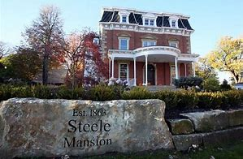

The Escape and Terrible Ordeal of General John C. Breckinridge
By Paul Siedel

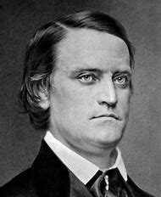
One of the most interesting episodes following the collapse of the Confederate Government and its flight from Richmond is the ordeal of former U. S. Vice President and Confederate Secretary of War John C. Breckinridge. After the fall of Richmond in April 1865 the Confederate Government fled southward to Danville and then on to Greensboro North Carolina. All government officials were finally captured except two, Judah Benjamin and Confederate Secretary of War John C. Breckinridge. Both made it out the country and to Cuba where they then made their respective ways to Great Britain and Canada. During the escape Breckinridge helped negotiate the terms of surrender between Sherman and Joseph E. Johnston. Afterwards he rejoined the presidential party making their way through North Carolina and it was at this time that Breckinridge became the de facto president of the Confederacy.
Breckinridge was there when the other members of the cabinet convinced Davis that the War was lost, and he recorded the terrible breakdown that Davis underwent. Several Confederate officers had made their way to the presidential party as it congregated in Charlotte, North Carolina. Among them Generals Vaughn, Basil Duke, Bragg and several others. At Abbeville South Carolina Breckinridge supervised liquidation of the Confederate treasury. Soldiers were paid off, and much was sent to Augusta, Georgia where it was finally seized by federal authorities. Contrary to popular belief very little was unaccounted for.
When the presidential party reached Washington, Ga. most members had already fled toward their respective homes, and Davis was by this time a marked man. Robert Toombs, the former Confederate Congressman, adamantly refused to let him into his home fearing reprisals when the Federal troops arrived. However General E.P. Alexander was planning to join the Davis party but was disappointed when he learned he had arrived just after the Davis party left. At this point Davis had accepted the defeat of the Confederacy and decided to go south toward Florida and contact with his wife and children. Breckinridge and Benjamin also left the party here and decided to make their way into Florida and then out of the country.
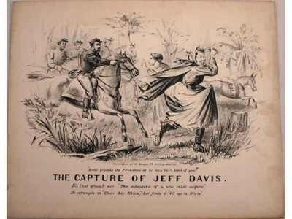
Breckinridge headed south to Abbeville, Georgia where he heard of the capture of Jefferson Davis. Breckinridge then released the last few escorts that accompanied him and with his son Cabel reached Madison, Florida on May 15, 1865. Little did he know that he and his party were paralleling the route of Judah Benjamin the two parties however never met until they reached Cuba. At Madison Breckinridge sent his son to Tallahassee to surrender to Federal authorities and get his parole. Here he met Captain John Taylor Wood, President Davis’s nephew. Wood was with the presidential party but escaped when Davis was captured. Breckenridge and Wood made their way southward and crossed the Suwannee River on May 17 before moving on into Gainesville, Florida. Here they met Col. J.J. Dickinson the Swamp Fox of the Confederacy who promised to secure them a boat in which to make it down the east coast of Florida and on to Cuba.
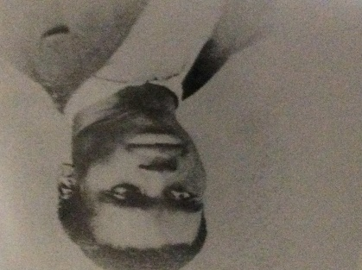
Breckinridge and his party left Gainesville and rode on through Ocala, and made it to Ft. Butler on the St. John’s River where they gave up their horses and met the man who would take them by boat south along the east coast. The sun was unbearably hot and the mosquitos were ravenous. Breckinridge, Wood and several others subsequently made their way along the east coast of Florida. Among them was Thomas Ferguson, Breckenridge’s African American valet who had been with him throughout the war and who subsequently would stay with the party until they arrived in Cuba. After crossing the St. John’s River they headed east, arriving at the Atlantic Coast near present day Cape Canaveral. The party pressed on along the coast hiding during daylight hours and traveling by night. They passed the Union outpost at Fort Lauderdale, and hid in the swamps surrounding Fort Dallas at the mouth of the Miami River where they arrived on June 7, 1865. From here they made their way across Biscayne Bay fighting a band of renegades who inhabited the swamps around the Bay and then set out across the straits of Florida, surviving storms, exposure to the hot sun and millions of hungry mosquitos. They ran out of water and were thoroughly dehydrated by the time they arrived in Cardenas, Cuba on June 12, 1865. After much rest and they went on to Havana and subsequently arrived in England on August 27, 1865.
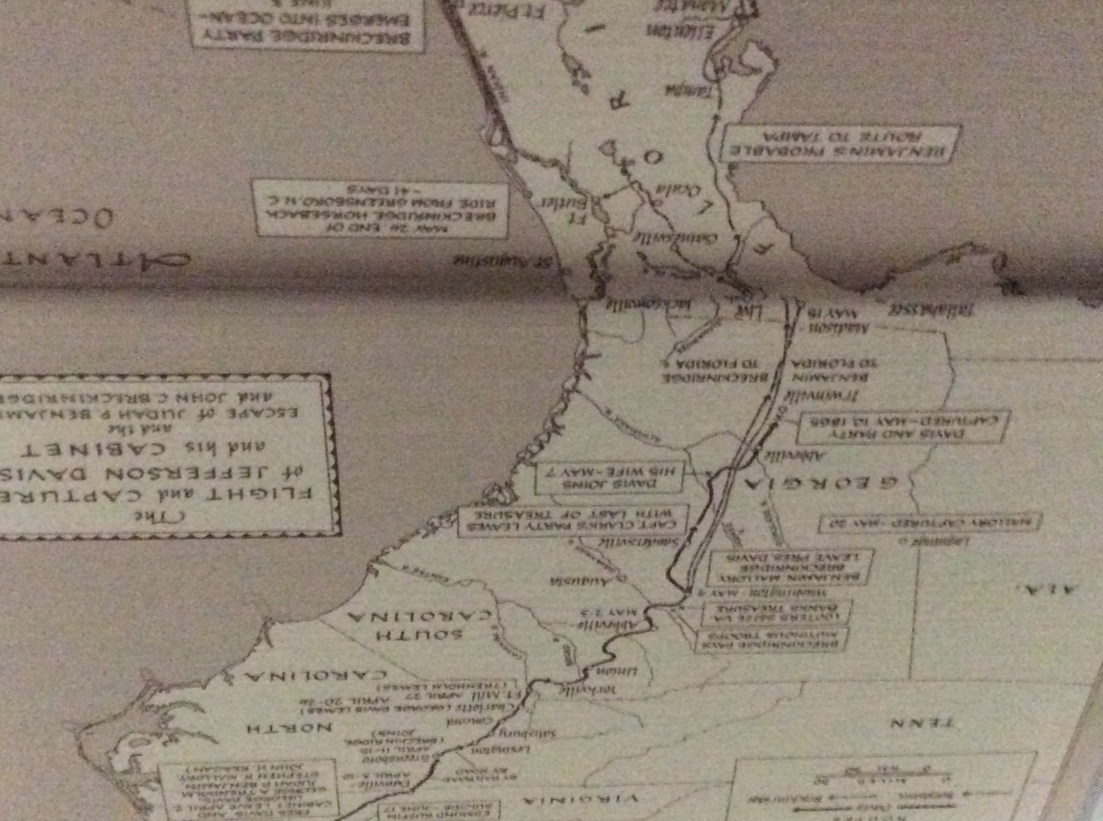
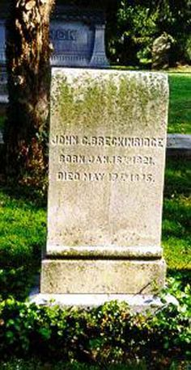
Breckinridge spent three and a half years in self-imposed exile in England before moving to Niagara on-the-Lake in Canada. In 1868 after President Johnston’s Christmas Amnesty at the urging of friends he returned to his native Kentucky. Breckinridge was urged to run for office but steadfastly refused. The War had taken something out of him and as he told a friend “Politically I am an extinct volcano”. He did however constantly urge understanding between the north and south, he condemned the Ku Klux Klan and championed the civil rights of former slaves. He died at 54 at his home in Lexington, Kentucky, exactly ten years after crossing the Suwannee River on his flight into Florida.

RESIDENTIAL COMMERCIAL
440-669-8330
Bernie Taub Competitive Pricing
Master Technician Excellent Service

TRUCK MOUNT
STEAM CLEANING
FREE PRETREATING
FREE SCRUBBING
FREE DEODORIZING
24-HOUR FLOOD SERVICE

