THE COURIER
Northeast Ohio Civil War Round Table
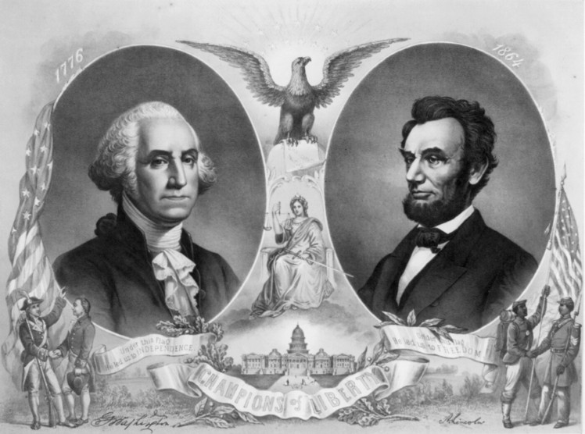
Tuesday February 12, 2019 Meeting #185
Canteen: 6:00 pm Dinner: 6:45 pm Program: 7:45 pm
Pine Ridge Country Club
30601 Ridge Road, Wickliffe, Ohio
Program: “Kate Chase”
Speaker: Norty London
Reservations Required * Guests Welcome
e-mail: francomichael2414@yahoo.com or phone (440) 567-2414

2019 NEOCWRT Officers & Committees
Founders: Bob Baucher, Norton London, Joseph Tirpak, Frank Yannucci
President: Kenny Godnavec Vice President: Tom Horvath, Jr.
Secretary: Scott Hagara Treasurer: George Maier Courier Editor: David Lintern
Sergeant-At-Arms: Steve Abbey, Bill Wilson Event Coordinator: Franco
Membership Coordinators: Franco, David Lintern Website: Tom Horvath Sr.
Pay Your Dues at the Door! $55 Individual $75 Couple
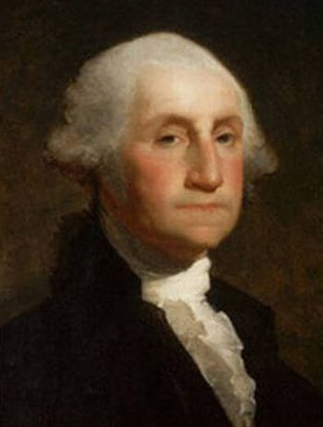 Kate Chase 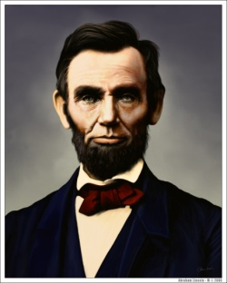
Catherine J. Chase
Daughter of Salmon P. Chase

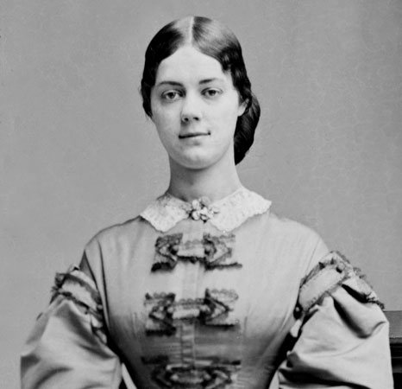
Referred to as “American Queen”, Norty’s talk will be about the rise and fall of Kate Chase Sprague, Civil War belle of the north. She was the most politically powerful woman of the 1860’s. Her life spans adventures from riches to rags. When her father was elected Governor of Ohio, she became his first lady and secretary.
Salmon Chase campaigned for and lost the Republican presidential nomination in 1860, after which he became Lincoln’s Treasury Secretary. Once in Washington, Kate became the premier hostess in the city. All of Kate’s ideas and planning were designed to further her father’s career.
While travelling to Cleveland, Ohio, Kate met William Sprague IV, boy Governor of Rhode Island and heir to a textile empire. Their wedding was the social event of the decade. Kate spent most of her married life in Washington helping her father politically. Sprague ran the family business in Rhode Island, travelling to Washington when Congress was in session as had been elected to the United States Senate. This was not a good recipe for a happy life.
The one man who measured up to Kate’s standards and shared her burning ambition, her father, would never achieve his ultimate goal. Losing a presidential bid in 1864, with Kate pushing for his success, Salmon Chase was appointed Chief Justice of the Supreme Court, much to Kate’s chagrin.
Kate entered into a very public relationship with Roscoe Conkling, the married and powerful senator from New York. No matter how one interprets her historical legacy, Kate Chase was one of the most influential women of her time.
Norton (Norty) London
Norton has been interested in Civil War history since childhood. He teaches 19th Century American history at Cuyahoga Community College in the Encore program and Baldwin Wallace University in the Institute for Learning in Retirement program. Before that, he was a history instructor at the Lakeland Community College for Adult Education.
He is a founder of the Northeast Ohio Civil War Roundtable and a member of and past president of the Cleveland Civil War Roundtable. He travels extensively on history field trips and attends seminars on the Civil War.
He is a retired real estate manager and is married to his wife, Joni, living in Cleveland Heights when they are not traveling around the country visiting their four children and four grandchildren.

CIVIL WAR JOURNAL of Franco M Sperrazzo February 12, 2019

JANUARY 8th MEETING: John A Sandy & Franco M Sperrazzo “Civil War & Current Events Challenge”. We created 4 teams consisting of 4 players each to test your knowledge on topics of Civil War, American/World History, Current Events, Music & Sports. We thank all participating members, featuring 8 members of 2 winning teams that were awarded prizes. The 8 members of the 2nd place teams received consolation books from the NEOCWRT library. The 37 people present appeared to be enjoying the double set of quizzes by interacting and 2 astute members of the audience were too rewarded with gifts. Our club last did a similar program in July 2017 during our James A. Garfield NHS Speaker Symposium at Lawnfield. We shall revisit the idea of conducting this format of History trivia for a future program. Your feedback is welcomed in order to determine the popularity of our audience involvement presentation.

NEOCWRT 2019 MEMBERSHIP DUES: This is your 2nd notice. Treasurer George Maier, Sergeant of Arms Bill Meissner & William Wilson will be stationed at the entrance door. Provide cash/make checks payable to NEOCWRT, mark memo 2019 dues. INDIVIDUAL $55. COUPLE $75. Kindly keep your $25. dinner program payment separate.

NEOCWRT 2019 SPEAKER PROGRAM FLIERS & BUSINESS CARDS: This is your club with 9 monthly programs plus the July Speaker Symposium with our friends partnership at James A, Garfield NHS. We ask your cooperation in distributing the program schedule in places of significance that could attract prospective members, authors and historians. Ask me for your fair share at the next meeting.

MENTOR PUBLIC LIBRARY, “LEADERS & LEGACIES of the Civil War”. Located on main campus Mentor Avenue in the Garfield Room. Learn more of the life of Colonel now Professor Joshua Lawrence Chamberlain, who following his victory on Little Round Top on the 2nd day of Gettysburg became the brevet major general chosen to receive the ceremonial surrender of the Confederate Army of Northern Virginia, April 9, 1865. The program is free and open to the public. Reservations requested. Presenters are JAGNHS Park Rangers & volunteers. The government shutdown is on hold therefore the program is on.

EXECUTIVE COMMITTEE MEETING JANUARY 27th @ Cracker Barrel Restaurant
The Winter meeting was conducted by our NEOCWRT 22nd PRESIDENT Kenneth Godnavec, during the eve of the Polar Vortex. Among the topics of discussion were: review of the Fall 2018 meeting minutes; Treasurer Maier report. Business reports: Tirpak assigned John and Franco to form a committee to audit where the club is now, and where we want it to go. Lintern volunteered to takeover maintaining the membership roster. Sandy will soon be relinquishing his dinner duty of setting up the club’s laptop, which means we’ll need a replacement asap if we want power-point programs. Sperrazzo passed out speaker program fliers and business cards. We had a discussion but no decision on our One Day Spring excursion. Should you have an interest or suggestion on any of these subjects, please discuss your ideas with a club officer.

NEOCWRT 2019 Officers & Committees Continued: Updates to the President Godnavec Administration. Lintern and Franco will head the Membership Committee. John Sandy, Ted Karle, Paul Seidel & Franco will plan the One day Spring excursion. Vice-President Tom Horvath, Jr. heads our 2020 Program Committee. Anyone wishing to serve can contact Tom.

MEMBERS & FAMILY HEALTH CONCERNS: We recently made phone contact with Mike Sears and have made arrangements with his wife Donna, for a home visit before our February meeting. He sounded quite encouraging in our conference call as we look forward to spending quality time with him. John Sandy and this writer did spend time with Hudson Fowler 111 at his home with Wife Nancy. He is rehabbing from health matters. We shared an outstanding afternoon together. Keep Hudson and member Jack Hattendorf (his brother-in-law) in your thoughts as Jack also has been absent from our CWRT due to health problems. Founder Bob Baucher had testing performed in January but plans to return in February.

Stay safe, well & warm! Enjoy Super Bowl 53 Belichick/Brady 30 McVay/Goff 27 Franco

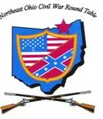 Editorials

As expected, last month’s editorial has prompted some responses. Read on.

A PERSPECTIVE ON THE CONFEDERATE FLAG
By Ted Karle
It has been stated that NEOCWRT should no longer fully display the Confederate Battle Flag on our stage as to many it has become a symbol of hate. The viewpoint suggests that the flag be confined to a small triangular box, presumably, displayed on our dais. The objective is to eliminate the risk that some might classify our group as sharing sympathy with ‘white supremacists.’ Confinement would also show our respect to those who view the flag as the “pariah of evil” dividing our country.
Understand that the anti-Confederate Flag movement nationwide is a part of a wider activity that seeks to denigrate other elements of our founding, its fathers, our economic system and our history. We need to be careful at our confinement of the subject signal our agreement with this larger agenda afoot in our nation. We, unwittingly, by adopting the confinement posture confirm our acceptance of the tenets of this broader social history revisionist movement. The NEOCWRT as an organization should remain neutral to such forces while it members can believe as they choose.
NEOCWRT is fundamentally a historical organization in objective, purpose and practice; it is in no manner political. It does not endorse political positions, parties, or activities, or partisanship. Our thrust is educational. No one could attribute any of our activities as fostering HATE by our displaying the Confederate Battle Flag. The twenty-plus years of our existence through our speakers, our activities and newsletters all attest to the purity of our motives. We need not apologize for our goals or our activities. By not confining the flag, we need not explain why it is confined.
The NEOCWRT every right to own a Confederate flag. We will never use our flags to demean any group. All, thinking people, will recognize and affirm our right to express our First Amendment right to display our flags as we choose. We need not hide or cover our emblems in order to satisfy some “political correctness” view of others or even some of our members.
The censoring the Confederate Battle Flag diminishes an even-handed presentation of history as we understand it. We recognize that our members and guests hold many diverse opinions on history and their particular heritage. Our two flags make a clear, unambiguous statement that we endorse Civil War history as it occurred. We permit everyone to express his own interpretation. In that sense, our “house is divided.,” that is its strength and not its downfall.
The Confederate Battle Flag has been stripped from certain public venues. That is not a reason that NEOCWRT should do the same. As established, our purposes are different. We need not be intimidated by outside groups; our opinions are as valid as any they might hold. For example, the fact that the NPS gift shop at Gettysburg no longer sells the subject flag only affirms that they serve a wider clientele and have an agenda that seeks to mollify criticism by certain public elements. In the meantime, NPS permits Civil War re-enactment groups to display the flag.
NEOCWRT pledges allegiance to its 1863 National Flag to open its meetings. The Confederate Battle Flag stands humbly ignored and defeated as it did after Appomattox; it need not be boxed.

What should be done with the Confederate Battle Flag?
By ted Karle
That question was answered in two manners at the end of the War.
The first answer was at Appomattox. General Grant appointed Joshua Chamberlin to accept the surrender of the Confederate colors. Chamberlain wrote of the event: The Confederates preferred to stack their arms and colors in their camp rather than suffer the humiliation of laying them on the ground before the Federal army. Their request was denied.: “…feeling came over our hearts to make some recognition of this great, last meeting.” Orders were issued to each Union division along the roadside, that as the Confederate brigades entered its area, the division would order its arms in salute to the passing troops. “[Confederate] General Gordon outdoes us in courtesy…at the clatter of [our] arms…and instantly catching the significance…[he] wheels his horse…and drops the point of his sword to his stirrup, gives a command at which the great Confederate ensign following him is dipped and his decimated brigades…respond. All is in silence… as if it were the passing of the dead…a great wind would spring up from the south with a strange greeting; our starry ensigns stiffen and fly out as if to welcome back the returning brothers. The ensigns of rebellion seem to shrink back and strain away from the fated farewell.” One by one, each Confederate unit dressed its lines, fixed bayonets and stacked its arms. “…lastly, reluctantly, painfully, they furl their battle-stained flags and lay them down; some, unable to restrain themselves, rushing from the ranks, clinging to them, kneeling over them and kissing them with burning tears. And then the Flag of the Union floats alone upon the field…*
The second answer to the disposition of the Confederate Flag was supplied by Father Abram Joseph Ryan Catholic priest, and poet. He served as Chaplain of the 10th Tennessee where he had lost a brother in that unit’s service. It was late at night when the news of Lee’s surrender arrived at him. He took pen in hand and began to the write his thoughts in verse about the event. His eyes filled with tears. He finishes his poem, crumpled the paper and threw it away. The next morning his housekeeper retrieved the poem. She liked it and had it published in a newspaper. The poem went viral throughout the Southern and Northern states. (My copy of his book of poems (1888) is in its 12th printing.) Father Abrams became a famous public speaker reading his poetry in cities and villages all over the country. Poems such as the one below and his “The Sword of Robert E. Lee” were dear to the hearts of his countrymen.
Here are the sentiments that the priest wrote, and his suggestion as to what should happen to the the Confederate Flag:

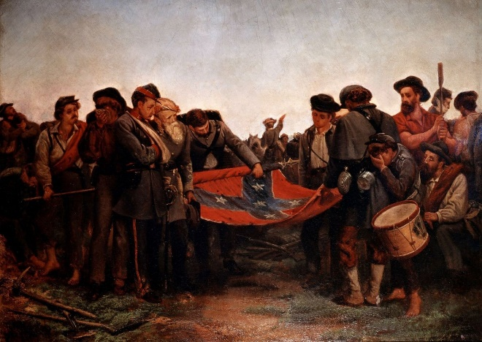
From the THE CONQUERED BANNER:
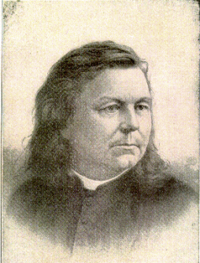
"Furl that Banner, for 'tis weary;
Round its staff 'tis drooping dreary;
Furl it, fold it, it is best;
For there's not a man to wave it,
And there's not a sword to save it,
And there's no one left to lave it
In the blood that heroes gave it;
And its foes now scorn and brave it;
Furl it, hide it--let it rest!
Take that banner down! 'tis tattered;
Broken is its shaft and shattered;
And the valiant hosts are scattered
Over whom it floated high.
oh! 'tis hard for us to fold it;
Hard to think there's none to hold it;
Hard that those who once unrolled it
Now must furl it with a sigh.
Furl that banner, furl it sadly!
Once ten thousands hailed it gladly.
And ten thousands wildly, madly,
Swore it should forever wave;
Swore that foeman's sword should never
Hearts like theirs entwined disserver.
Till that flag should float forever
O'er their freedom or their grave!
Furl it! for the hands that grasped it,
And the hearts that fondly clasped it,
Cold and dead are lying low;
And that Banner--it is trailing!
While around it sounds the wailing
Of its people in their woe.
For though conquered, they adore it!
Love the cold, dead hands that bore it!
Weep for those who fell before it!
Pardon those who trailed and tore it!
But, oh! wildly they deplored it!
Now who furl and fold it so.
Furl that Banner! True, 'tis gory,
Yet 'tis wreathed around with glory,
And 'twill live in song and story,
Though its folds are in the dust;
For its fame on brightest pages,
Penned by poets and by sages,
Shall go sounding down the ages--
Furl its folds though now we must.
Furl that banner, softly, slowly!
Treat it gently--it is holy--
For it droops above the dead.
Touch it not--unfold it never,
Let it droop there, furled forever,
For its people's hopes are dead!"

Furling The Flag (1871) by Austrian artist Richard Norris Brooke

Father Abram J. Ryan
(1838-1886)

*Chamberlain, Joshua L., The Third Brigade at Appomattox, found in the Appendix, in Norton, Army Letters 1861-65, Morningside edition, 352.

“Roads to Memphis”
By Debbie Weinkamer
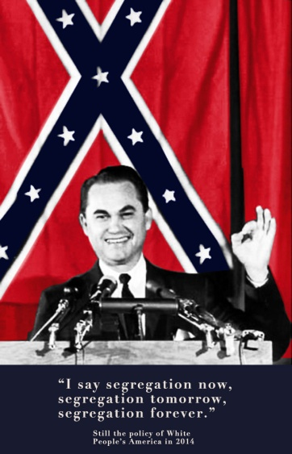
After recently watching American Experience’s documentary, “Roads to Memphis,” I am convinced more than ever that it’s appropriate to display NEOCWRT’s Confederate flag in a furled manner.
This program showed the story of two paths taken: one, of peaceful, non-violent protest for civil rights taken by Rev. Martin Luther King; the other of petty crimes, imprisonment, life on the run, and assassination followed by white supremacist James Earl Ray. The black-and-white photographs accompanying the documentary vividly demonstrated the seething, turbulent times. One that particularly stood out was of a group of young white men, in violent stance against a group of black men, waving Confederate flags. Also seen was a large Confederate flag as the backdrop behind Gov. George Wallace – a racist, third-party candidate for US President – while he delivered a speech at a podium in 1968. Another featured a car with “KKK” posted on the driver’s door, and a Confederate and U.S. flag flying from the front bumpers, symbolizing hate, white supremacy, and racism.
Even some Southerners rejected the flag and other symbols of the Confederacy in the post-Civil War years. Olivia Ortman, a contributor in “The Gettysburg Comiler” relates this story in 2017:
“The Confederate flag is one of the marks of war that [Robert E.] Lee removed from his own life. In one popular story, a Southern woman wrote to Lee asking what she should do with an old battle flag. Lee supposedly responded, ‘Fold it up and put it away.’ This has been a source of some contention, however, because no letter has been brought forward with these words. Regardless of whether Lee actually wrote these words, however, he did ask his children to keep the flag out of his funeral. He was buried in a plain suit, not his Confederate uniform, and other former Confederates in attendance were also asked not to wear their military uniforms. The Confederate flag was nowhere in sight that day. Its presence would only have served to open old wounds.”
If our club wants to display the flag that became a caustic symbol after the Civil War, and especially in the 1960s, it would be best to fold it and display it in that manner.

Should the NEOCWRT Display the Confederate Flag?

By Todd Arrington

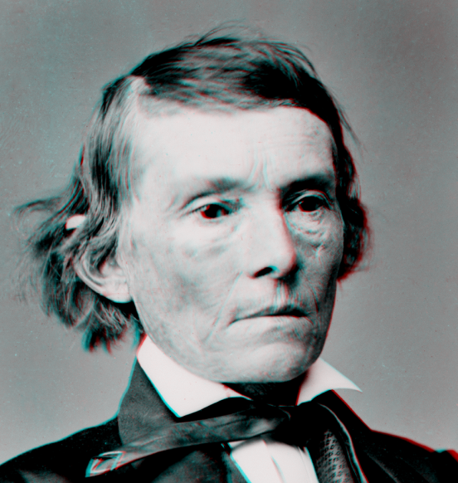
The new Constitution has put at rest forever all the agitating questions relating to our peculiar institutions—African slavery as it exists among us—the proper status of the negro in our form of civilization…

They rested upon the assumption of the equality of races. This was an error. Our new government is founded upon exactly the opposite ideas; its foundations are laid, its cornerstone rests, upon the great truth that the negro is not equal to the white man; that slavery, subordination to the superior race, is his natural and normal condition. This, our new government, is the first, in the history of the world, based upon this great physical, philosophical, and moral truth.

~Confederate Vice President Alexander Stephens, in his famous “Cornerstone Speech,” March 21, 1861.

Despite what many would have you believe, the Civil War was fought over the issue of slavery. Those who disagree often cite states’ rights, economics, different interpretations of the Constitution, and other factors as proof that the war was not about slavery, but all of these can be traced back to being offshoots of disagreements about slavery. Make no mistake: not all northerners were abolitionists, just as not all southerners were slave owners. But ultimately it was disagreement about the expansion of slavery into western states and territories that led the South to feel that its way of life and economic survival were at stake and that secession was their best option to preserve them. You don’t have to take my word for it, though. Alexander Stephens and countless other Confederates put it in plain English.

Today, we see monuments to Confederates being removed from public spaces and National Park Service bookstores taking Confederate flags off their shelves. But we also continue to see hate groups fly the Confederate flag as a symbol of pride and racist killers like Dylan Roof, who opened fire at an African American church in Charleston, South Carolina in 2015, flock to Confederate ideology and symbols. Obviously, people like this have other issues that make them behave the way they do, and the overwhelming majority of those who wish to see the Confederate flag continue to fly will never commit racially-motivated murder.

For good or ill, though, the Confederate flag has become a divisive symbol. (Of course, for African Americans, Union veterans, and others, it was always divisive.) When Confederates like Stephens leave behind powerful words that make it clear that the Confederacy was based on a racist notion of inequality, do we want one of that notion’s primary symbols displayed in public spaces or even at the meetings of the Northeast Ohio Civil War Round Table? Personally, I do not. This is not a rewrite of history; rather, it is an acknowledgement that we can appreciate and study the Civil War and still understand how deeply flawed was the reasoning behind the Confederacy’s attempt to secede and create a new nation based on human slavery and inequality.
My opinion is that the NEOCWRT can continue to be a thriving, engaging organization without displaying a Confederate flag at meetings. The representation of the Confederate flag within the Round Table’s insignia is enough.

It was a war of ideas, a battle of principles and ideas which united one section and divided the other; a war between the old and new, slavery and freedom, barbarism and civilization; between a government based upon the broadest and grandest declaration of human rights the world ever heard or read, and another pretended government, based upon an open, bold and shocking denial of all rights, except the right of the strongest…

There was a right side and a wrong side in the late war, which no sentiment ought to cause us to forget, and while today we should have malice toward none, and charity toward all, it is no part of our duty to confound right with wrong, or loyalty with treason.

~Frederick Douglass, “Speech delivered in Madison Square, New York, Decoration Day.” 1877.

First National Flag
By Paul Siedel
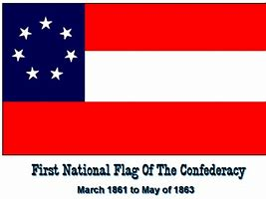
In regards to displaying the Confederate Flag, let me relate to you what happened to me. The Woodland Cemetery Foundation places flags on the veteran graves every Memorial Day. We have at least one Confederate Veteran buried there. The family wanted to know if they could put a Confederate flag on the grave of Henry Handerson (the family ancestor) who was part of a Louisiana unit. I told them that they needed to get in touch with the city as they were in charge of decorations at city cemeteries. I did, however, suggest that they use the First National Flag of the Confederacy. North Carolina and Georgia both have state flags based on it. I said that the Battle Flag would not stay there as someone would most likely take it down. They put up the First National Flag and it stayed there for several weeks until we took the others down. My idea worked. Not as much “in your face” and not many know what the First National flag is.

From the Editor
David Lintern
My thanks to those who contributed their opinions for this month’s Courier. It is clear that one side finds flying the Confederate flag appropriate for what is was, and the other side finds it inappropriate for what it has become. Two perspectives based on two contexts. I hope to receive more opinions for the March Courier. Discussions and debates are what Roundtables are about, and the table is round so no one sits at the head of it. Please join in, if only with a sentence.

Rather than place our Confederate flag in a triangular box, Richard Norris Brooke’s painting illustrates the accurate manner to display the flag; rolled up.
One by one, each Confederate unit dressed its lines, fixed bayonets and stacked its arms. “…lastly, reluctantly, painfully, they furl their battle-stained flags and lay them down; some, unable to restrain themselves, rushing from the ranks, clinging to them, kneeling over them and kissing them with burning tears. And then the Flag of the Union floats alone upon the field…

Furl that banner, softly, slowly!
Treat it gently--it is holy--
For it droops above the dead.
Touch it not--unfold it never,
Let it droop there, furled forever,
For its people's hopes are dead!"

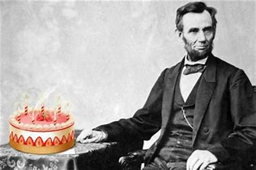
Happy Birthday Abe!

That Reminds Me of a Story:
That reminds me of the woman who once told me "I do believe you are the ugliest man I ever saw." Said I, "Madam, you are probably right, but I can’t help it!" "No," said she, "you can’t help it, but you might stay at home!"
Debating Douglas, Lincoln got a tremendous laugh from the audience when he said one of Senator Douglas arguments was “as thin as the homeopathic soup that was made by boiling the shadow of a pigeon that had starved to death.”
Two Quaker women were discussing Lincoln and Jefferson Davis at the beginning of the Civil War. The first Quaker lady said that she believed the Confederacy would win the war because "Jefferson Davis is a praying man." “But Abraham Lincoln is a praying man too,” the second lady protested. "Yes," the first admitted, "but the Lord will think Abe is joking."
Lincoln Quotes:
“Whatever you are, be a good one.”

“My concern is not whether God is on our side; my greatest concern is to be on his side.”

“Those who look for the bad in people will surely find it.”

“I dislike that man. I must get to know him better.”

All articles appearing in the Courier do not necessarily state or represent an endorsement of the facts, conclusions, and opinions of the author(s) by the NEOCWRT or its membership.

