THE COURIER
Northeast Ohio Civil War Round Table
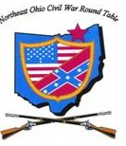
Tuesday December 10, 2019 Meeting #192
Canteen: 6:00 pm Dinner: 6:45 pm Program: 7:45 pm
Pine Ridge Country Club
30601 Ridge Road, Wickliffe, Ohio
Christmas Program
Civil War Music by Steve and Lisa Ball
Reservations Required * Guests Welcome
e-mail: francomichael2414@yahoo.com or phone (440) 567-2414

2019 NEOCWRT Officers
Founders: Bob Baucher, Norton London, Joseph Tirpak, Frank Yannucci
President: Kenny Godnavec Vice President: Tom Horvath, Jr.
Secretary: Scott Hagara Treasurer: George Maier Courier Editor: David Lintern
Sergeant-At-Arms: Steve Abbey, Bill Wilson Event Coordinators: Franco
Website Coordinator: Tom Horvath, Sr. 2019 Program Chairman: Tom Horvath, Jr.
Civil War Music
Steve Ball is a musician from Columbus specializing in the music of the American Civil War and the life and music of Stephen Foster. Steve has studied the Civil War since his teens and has devoted the past twenty years to studying the music of this era of American History. Steve has done programs for the Ohio Statehouse, the National Civil War Museum, the American Civil War Museum of Ohio, and countless historical societies, libraries, museums, Civil War Roundtables, and venues such as re-enactments and living historical programs.
Steve has released two CD’s of the music of the Civil War and is currently working on a CD of Stephen Foster tunes. Steve is also a narrator for the 73rd Ohio Volunteer Infantry Civil War Brass Band. He is a member of the Sons of Union Veterans of the Civil War, and a member of the Civil War Preservation Trust. Steve has played locally many times, including many return engagements at the James A. Garfield Civil War Encampment.
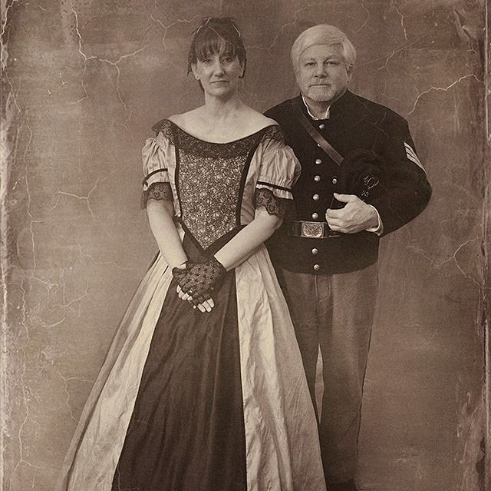

Robert Smalls and the Theft of the “Planter”
By Paul Siedel

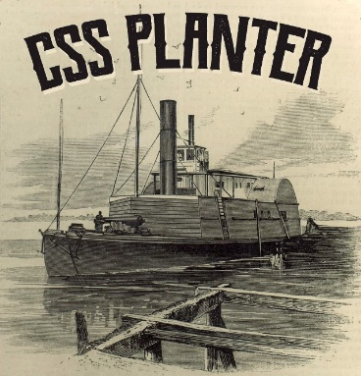
One of the most inspiring episodes of the Civil War was the daring raid by Robert Smalls and the theft of the CSS “Planter” on May 12, 1862. On visiting Charleston S. C. last year, I was surprised to run across a state historic plaque describing the episode and the aftermath on the Charleston waterfront. Not knowing much about the theft, I decided to look into it further. Here is what I learned.
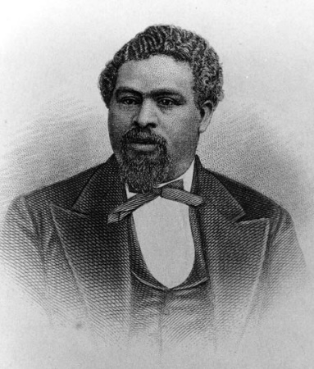
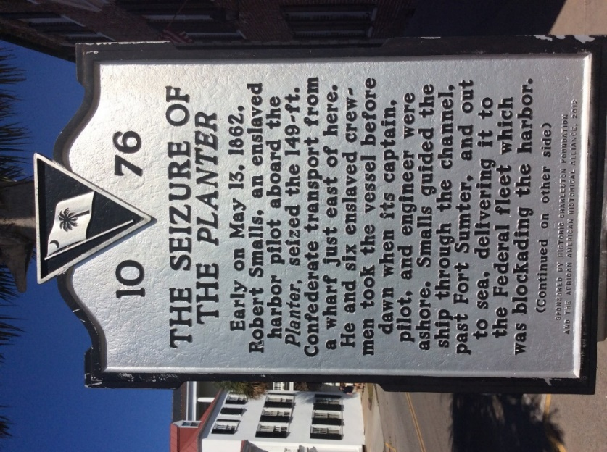
Robert Smalls was an African American born into slavery in Beaufort, South Carolina on April 5, 1839. He was taught to read and write, and although it was against the law in South Carolina, this made him much more likely to be hired out for a sizable sum. By 1862 he was owned by one Henry McKee and was hired out to serve on the 140 ft paddle-wheeler “Planter”, a cargo ship owned by one John Ferguson and chartered by the Confederacy for $125 a day. The “Planter” eventually became the flagship of General Roswell Ripley, second in command of the Confederate defenses at Charleston. The actual captain of the ship was Captain J. Relyea. Smalls was extremely literate and so Henry McKee hired him out to Relyea for $18.00 a day, of which Smalls was only allowed to keep $1.00! Smalls showed his aptitude for things mechanical and was soon promoted to wheelsman, the highest rank allowed to an African American. He soon became familiar with the defenses of Charleston, the forts, their strengths and weaknesses, torpedo positions and the positions of the Rebel ships. Smalls soon realized he could use this information and his position to his advantage in an attempt to gain his freedom and that of the other members of his family. So, on the night of May 11, 1862 he escorted a group of civilians, including Capt. Relyea, over to Fort Sumter for an evening of music and dancing designed to shore up morale in the Confederate held fort. He waited until 3 A.M when he had a full head of steam in the boilers, and then silently backed out of the moorings and headed for the Cooper River to pick up his family. Once there he picked up eight people, including his wife Hannah and his baby daughter Elizabeth. He then headed back towards Fort Sumter for the U.S. fleet three miles beyond. As they steamed past the fortifications he pulled the captain’s hat down over his face. From a distance he looked remarkably like Captain Relyea. They steamed past Ft. Johnston, past Morris Island, and finally met the USS “Onward.” Questions were exchanged across the water, and the men of the “Onward” couldn’t believe their ears. An officer went aboard the Planter to investigate. Smalls was standing at attention. “Sir I bring you the “Planter” and we have come to join the U.S. fleet.” Smalls and his ship did go on to join the Union fleet and Mr. Smalls, (he was no longer called boy) went on to live fifty-three more years. When he died in 1915, he had served in the U.S. Congress, and in South Carolina’s legislature, doing much to enhance race relations in the state and helping to make us one country undivided and reunited.
U.S. history seems to be filled with stories of daring and courage and lesser known actions and folks that after the conflict ended faded back into their lives of good citizens. It is to folks such as Robert Smalls and others that we owe much of what we are today for they contributed just as much as did the generals and politicians that we hear so much about.
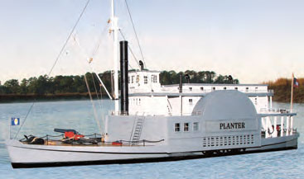

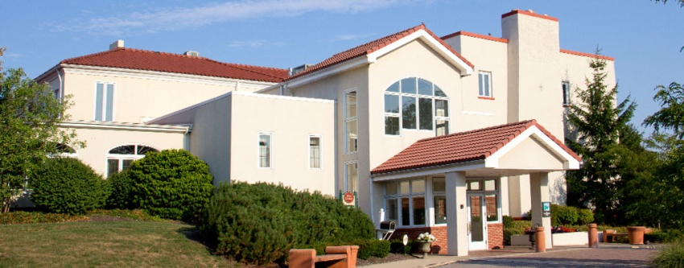

Pine Ridge Country Club
November 12, 2019

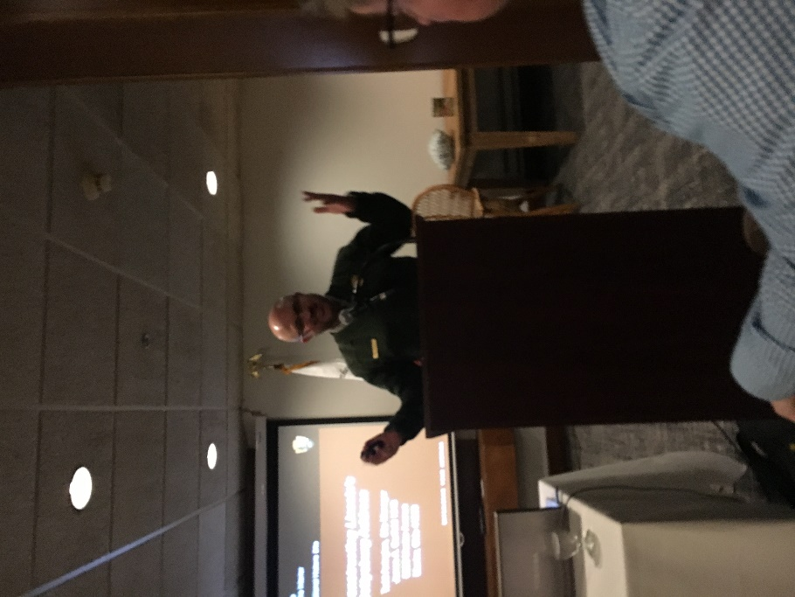

Dr. Todd Arrington received high praise for his talk “De-Constructing the Gettysburg Address.” One member called it one of the finest programs he’s ever seen at our club dinners.
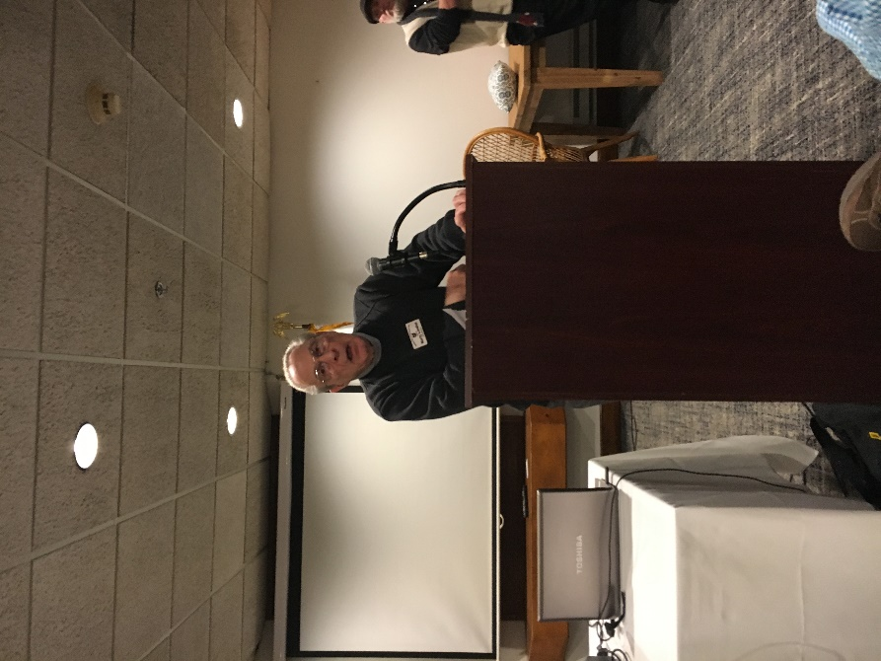
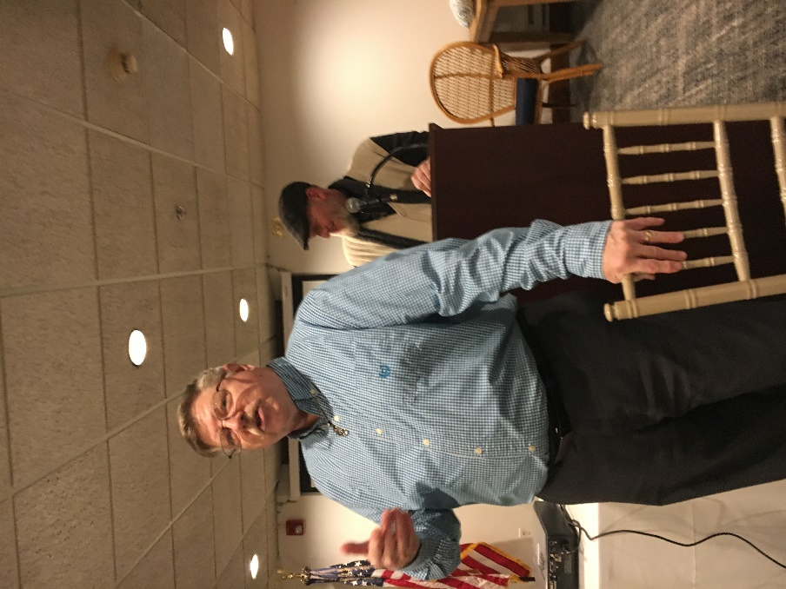

Norty and Craig address the membership.

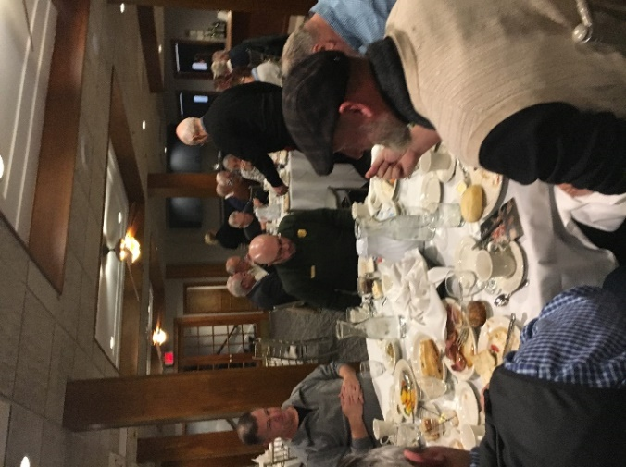
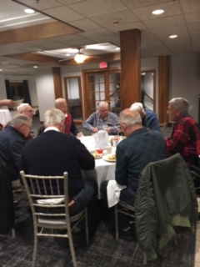

29 members and a guest having great food and a great time!
As the majority of our members socialize and drink cocktails before dinner, other members are busy working. Below are three club MVP’s who man the check-in table each month. Here’s a big thank you to Treasurer George Maier, and Past Presidents Bill Wilson and Steve Abbey.

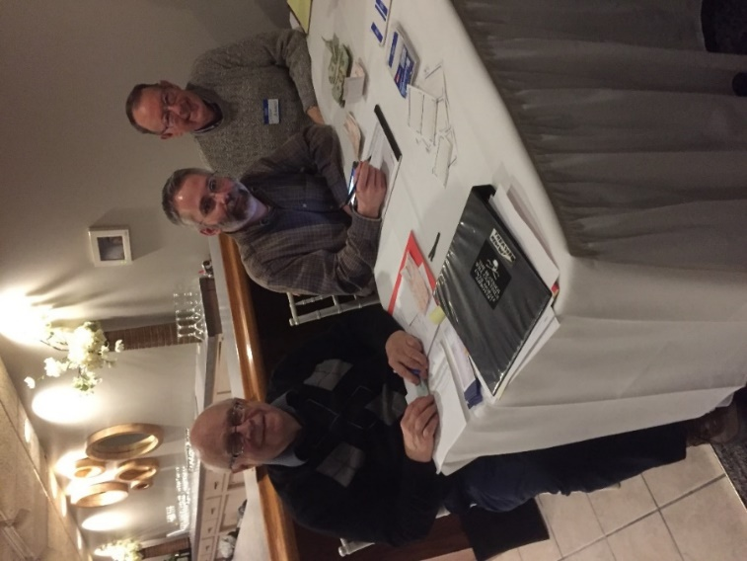

CIVIL WAR JOURNAL of Franco M Sperrazzo December 10, 2019

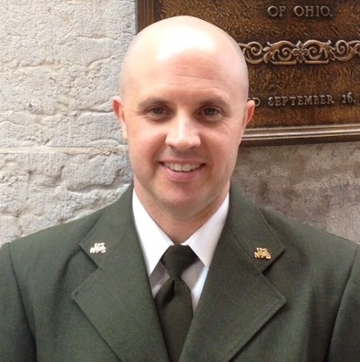
NOVEMBER 12th MEETING, Dr Todd Arrington, James A. Garfield Site Manager and NEOCWRT fellow member dazzled his audience with his line-by-line interpretation of the Gettysburg Address. In his revised version that several may have originally heard at the Mentor Library Civil War lecturer series, Todd dissected how some of the 271 words may have been misinterpreted. Versus like, “All men are created equal”. President Lincoln, did not specifically state Caucasian men but many believe he may have been referring as much. The 3/5th a person delegated for black slaves sparked light controversy that led to one of our most hefty questions and answer sessions in a long time. Dr. Todd, delivered so much significant information in a 45-minute PowerPoint presentation that also generated the 20-minute aforementioned Q & A.

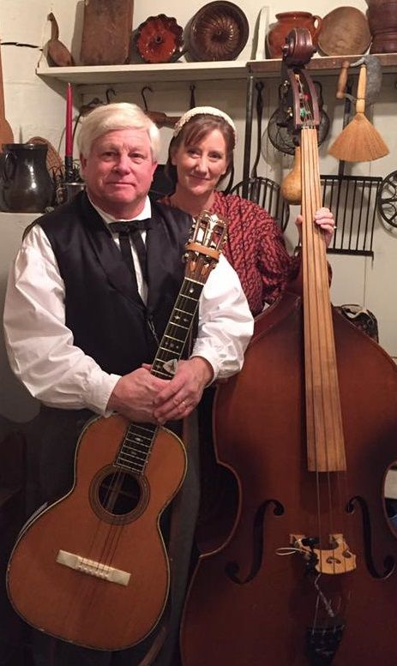
STEVE & LISA BALL of COLUMBUS, OHIO: “Civil War Music” @ Our December 10th Meeting. Having seen them perform patriotic music beloved by both the Confederacy & Union at various Civil War Encampments & Hale Farm & Village, I can say first hand they are worth the price of admission and more. We will be treated to our special Dino’s Catering Holiday food cuisine whereby for our regular priced $25. Dinner fee, offers a 3rd main course of chicken, baked fish and sirloin beer tips. The price increase is compensated by the NEOCWRT TREASURY. Please act considerately and call ahead your RSVP to confirm your seat in main Grille Room. This will be our warmer first floor room with the intimate setting.

MENTOR LIBRARY - Wednesday, December 11th from 12-1pm.
“CHRISTMAS IN CAMP” - How did Union and Confederate Soldiers identify the Holiday Season in their Winter Camps? Learn of the oddity of unofficial Civil War truces! PROGRAM IS FREE AS ALWAYS! Presentation produced by JAGNHS Park Rangers/Site Volunteers. Bring your beverage & snack.

PROPOSAL FOR A 10th OFFICIAL MEETING, to occur in Later Spring 2020: This program would take place in the afternoon and be a luncheon starting perhaps noon and last until 3pm. We took a straw poll at our November meeting and the initial reaction was favorable enough to peruse the idea. The purpose is to allow for members who are having difficulties driving at night due to medical issues; for people with evening conflicts and for a change of pace to adjust to the needs of our NEOCWRT aging population. Location to be determined but we have places in mind. Since I initiated the proposal, I will take lead and ask our program cabinet members to work with me & support the endeavor. This is on the agenda for the January 2020 Executive Committee Meeting.

KEEPING OUR FAMILY & FRIENDS in the forefront during the Holiday Season. Several members or core family experience problems that are magnified this time of year. People struggle mentally, physically and financially. Keeps those people you care about on close watch. One of our Founders (Frank Yannucci) has been in & out of the hospital. Keep Frank and others in your thoughts and prayers. To all, Happy Chanukah, Merry Christmas & healthy, safe New Year 2020!

Captain Francisco Franco

