THE COURIER
Northeast Ohio Civil War Round Table
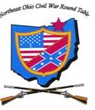
Tuesday April 9, 2019 Meeting #187
Canteen: 6:00 pm Dinner: 6:45 pm Program: 7:45 pm
Pine Ridge Country Club
30601 Ridge Road, Wickliffe, Ohio
Program: The Battle of the Crater
Speaker: A. Wilson Greene
Reservations Required * Guests Welcome
e-mail: francomichael2414@yahoo.com or phone (440) 567-2414

2019 NEOCWRT Officers & Committees
Founders: Bob Baucher, Norton London, Joseph Tirpak, Frank Yannucci
President: Kenny Godnavec Vice President: Tom Horvath, Jr.
Secretary: Scott Hagara Treasurer: George Maier Courier Editor: David Lintern
Sergeant-At-Arms: Steve Abbey, Bill Wilson Event Coordinator: Franco
Membership Coordinators: David Lintern, Franco Website: Tom Horvath Sr.
The Battle of the Crater, a Perfect Hell of Blood
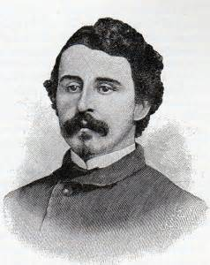
When Lt. Col. Henry Pleasants, a mining engineer, learned his 48th PA was only 130 yards from the besieged rebel lines at Petersburg, he talked Burnside and Grant into allowing his regiment to dig a tunnel underneath the enemy’s position. A skeptical Grant approved the idea as a “mere way to keep the men occupied.”
Five weeks later, at 4:44am, July 30th, 1864, the Army of the Potomac’s greatest (arguably) fiasco of the war began. Burnside’s plan to have his well-prepared African-American troops lead the advance had been reversed the day before by Meade and Grant. For political reasons, they wanted white troops. Burnside was forced to send in untrained troops at the last minute. They had no tactical training for this particular detail, and were unaware they were to charge around the scene of the explosion on their advance into Petersburg. Regiment after regiment charged directly into the crater. They became sitting ducks. Thousands were killed, wounded, and taken prisoner. By 2pm it was over. Federal casualties numbered over 4,000.
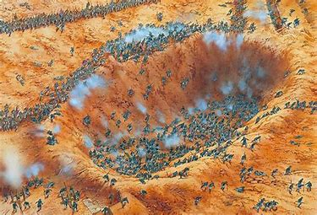
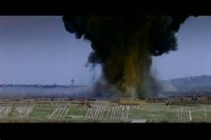

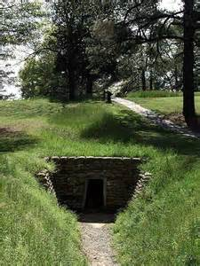
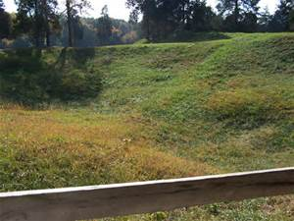

- Wilson Greene

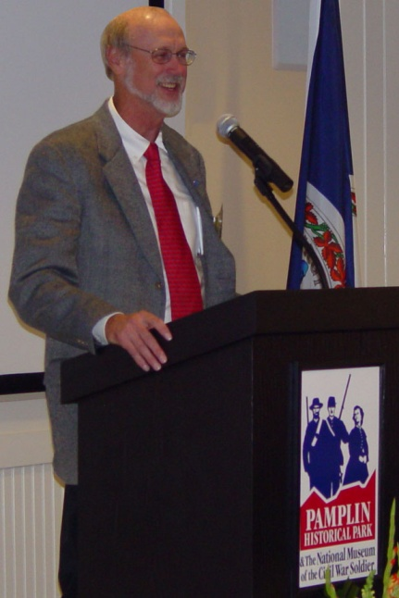
Allen Wilson Green, a.k.a., A. Wilson Greene, is an American historian, author, and retired museum director. Born in Chicago, he received his BA from Florida State University, and his MA from LSU. After college he joined the NPS as a historian at a variety of locations, including Fredericksburg, Spotsylvania, and Petersburg National Battlefield.
He was the first president of the Association for the Preservation of Civil War sites from 1990 to 1994. He was selected as a script reviewer for the 1993 film, Gettysburg, and was an adviser for the sequel film, Gods and Generals.
In 1995, he became the first executive director of Pamplin Historical Park, and, in 1999, the first director of the National Museum of the Civil War Soldier. He remained the director of both until his retirement in 2017. In 2005, President George W. Bush appointed him to the oversight board for the Institute of Museum and Library Services. As of 2018, Mr. Greene has made ten appearances on C-SPAN.
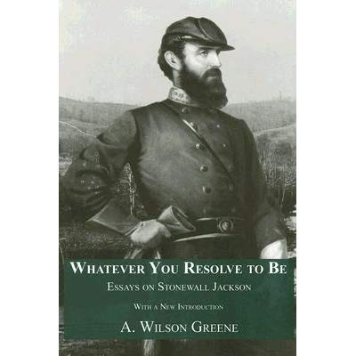
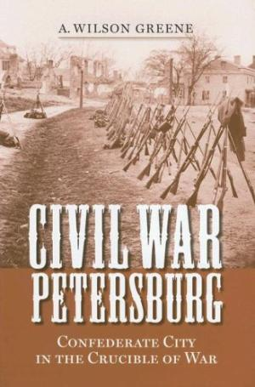
Today, Mr. Greene lives with his wife, Maggie, in Walden, Tennessee. From there, he continues his research and writing on the American Civil War.

Book Review
The Civil War at Sea by Craig Symonds
By Scott Hagara
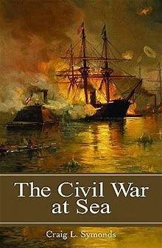
I have used the cold evenings this past winter to try and expand my Civil War knowledge by watching a number of civil war symposiums and lectures on YouTube. One of my favorite speakers is Craig Symonds, who is Professor of History Emeritus at the U. S. Naval Academy. A distinguished naval historian, he also is an excellent author and has written a number of books on naval history. The only thing I knew about navies in the Civil War was the story of the USS Monitor and the CSS Virginia (formerly the USS Merrimack) and the fact that there was a substantial blockade by the Union in force as a part of the Anaconda plan. With that limited knowledge base, I picked up The Civil War at Sea.
The Civil War at Sea provides a relatively concise history of an aspect of the war that is often overlooked. It tells the story of the Union and Confederate navies during a time of great innovation and technological advancement. It describes the various theaters of naval operations, from rivers to oceans, and features some wonderful stories of the leading characters of naval history, from names as familiar as DuPont, Buchanan, Porter and Farragut to a number of lesser known figures who played a vital part in the conduct and outcome of the war.
The U.S. Navy was ill prepared for the outbreak of war in 1861. It has been documented that there were fewer than 90 ships available, and as few as 40 capable of active service, hardly a “fleet” required to command the coastline, impose an effective blockade, pursue commerce raiders and support other military requirements. The years prior to the war, however, had seen a number of technological advances that fostered a quick transformation to a much more modern and effective navy. This expansion saw the Navy authorize the construction, or purchase, of many propeller-driven steamers, armed with the latest and most sophisticated naval ordnance. Warships became more maneuverable and deadlier than ships prior to the war. Many more innovations, including armor plate and the revolving turret, were soon to follow. The war years would see a huge expansion of the U. S. Navy, from ironclads to steamers, to allow it to fulfill its mission.
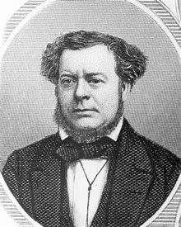
The Confederacy began the conflict with no navy at all. A few ships that were in southern waters were seized immediately after secession, but they surely could not be called a navy. Confederate authorities urged southern-born U.S. Navy officers to return to their home states and “bring with you every ship and man you can.” The Confederates knew that they would conduct largely a land war, so their naval needs were different. They hoped to employ small gunboat squadrons to support land fortifications and protect their shipping ports. Stephen Mallory, the Confederate Secretary of the Navy, worked to develop shipyards, iron foundries, and gun works to support his navy, but lacked the infrastructure needed to support these efforts. The Confederacy never had the needed resources, from iron to maritime engines, to build a large navy. It did, however, use assets such as private ships to run blockades and enjoy the lucrative market for successful missions.
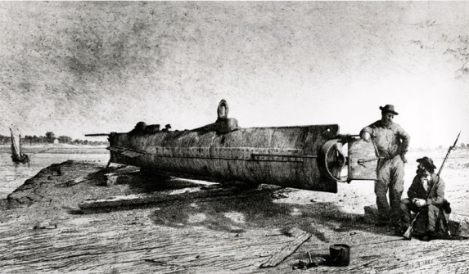
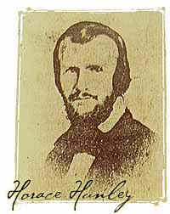
The Civil War at Sea is very well written and quite easy to read. The book is structured mainly by topic rather than in chronological order. Chapters include the technological revolution, the blockade and blockade-runners, the war on commerce and the river war. It also outlines the various sieges such as Charleston and Mobile, and the terrific story of the CSS Shenandoah, who made a round the world cruise, capturing thirty-eight prizes, before dropping anchor and striking her colors on November 6, 1865, effectively ending the Civil War at sea. I really enjoyed this book and highly recommend it. I am amazed at how both navies were so creative in their conduct of operations. For example, the Union in coordinating efforts of the army and navy to secure various targets such as Fort Donelson in Tennessee or Fort Fisher, North Carolina. The Confederacy, as it worked to develop and employ boats such as the H. L. Hunley to dent the Union blockade that was starving the south of much needed resources. I can only appreciate and applaud the bravery of sailors that would volunteer for duty on the first “submarine”, one that had already failed two practice runs and claimed over a dozen lives, including that of her inventor, Horace Hunley. I found it fascinating to learn of the foreign intrigue involved in the naval war. This involved building warships in foreign ports and the efforts to allow or stop this practice. The evolution of ship development, including ironclads, timber-clads and cotton-clads, in addition to the way they were equipped and manned, was very enlightening and made for wonderful reading.
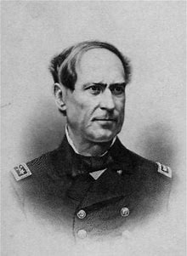
Anyone interested in this topic should also check out “60 Years of Service – The Life of Admiral David G. Farragut”, presented by our own Todd Arrington during the Mentor Public Library’s Civil War Leaders and Legacies series in October, 2018. This is available on YouTube and is a terrific presentation.
The Civil War at Sea, written by Craig Symonds, was published by Oxford University Press in 2009. The book is 209 pages and is not available at the Mentor Public Library, but is available through the inter-library loan system. The book I read came from the Cuyahoga Falls Library. It is also available in paperback (shown below) on Amazon at $19.95.
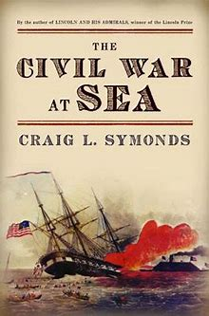

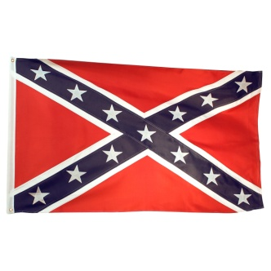
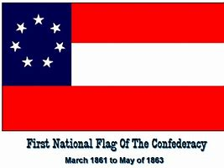
A Visit to Hollywood Cemetery
By Paul Siedel

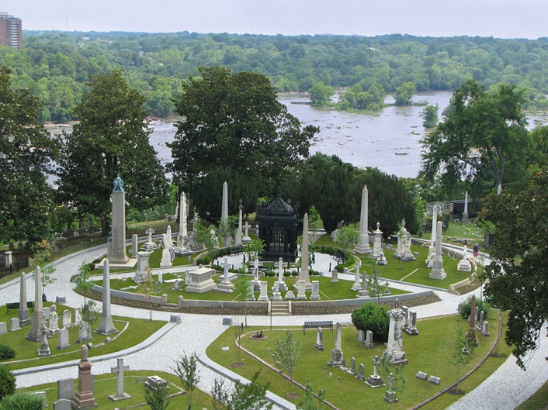
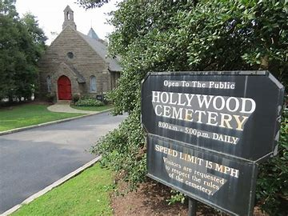
Any Civil War buff visiting Richmond, Va. will naturally come upon the many sites which were prominent during the conflict. The Confederate White House, The Confederate Capitol Building, the prison site at Belle Isle, the battlefields around the City and many more. However many folks miss one of the more prominent sites which although was an integral part in Civil War history it was not the site of any conflict or major legislation which effected society. It is located on South Cherry St and overlooks the James River in close proximity to The Tredegar Iron Works. The site of which I’m referring is Hollywood Cemetery. It comprises about 110 acres on the City’s western edge and is the resting place for nearly 18,000 Civil War casualties. Begun in 1849 with just a few burials architect William Pratt was hired in the 1850s to create a proper cemetery. Hollywood was enlarged and laid out at this time and by 1860 it had been named and incorporated. During the Civil War so many casualties were taken there that the grave diggers could not keep up with the influx of bodies. As a result the city fathers became concerned about the health situation and so the bodies began to be buried in long trenches which can still be seen today along with the hundreds of markers delineating the men buried there. Some of the most prominent figures however were still allowed to be interred in private graves. Hollywood Cemetery is also the resting place for two presidents and many who figured prominently in Virginia history down through the years. Burials are still taking place in 2019.
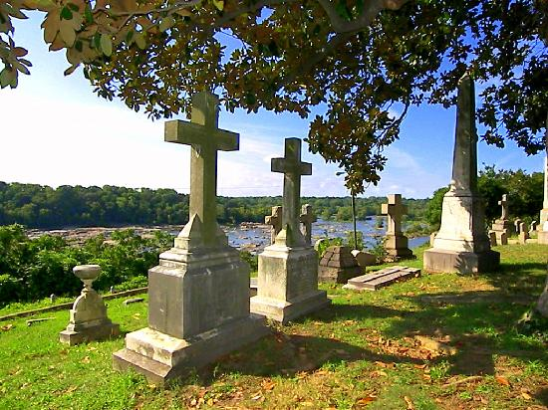
As you enter the Cemetery stop and get a map which will direct you to the prominent burials within the Cemetery and will give one a short history of the land and cemetery itself. Many of the monuments are individual works of art such as are the many monuments at Lakeview and Woodland Cemeteries in Cleveland. As you make your way through the area, you will see the headstones of Jefferson Davis, J.E.B. Stuart, and George Pickett. Pickett’s headstone is a huge pyramid dedicated to the Army of Northern Virginia which also contains the remains of thousands of men who were exhumed from the Gettysburg Battlefield in the 1870s.

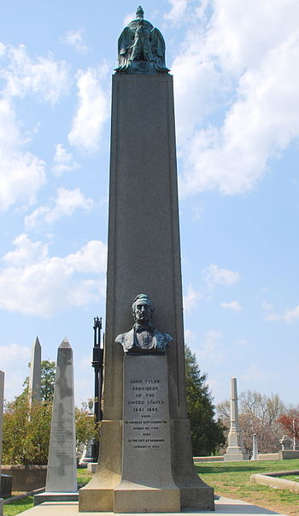
As we looked at the many markers marking the trenches we were informed that the markers for U.S. soldiers are rounded at the top, but markers for Confederate soldiers are usually pointed, a fact of which I wasn’t aware. I was also unaware of the fact that in 2019 one may still get a marker for their Confederate ancestor from the Veterans Administration. As one reaches the back of the property and gets closer to the bluff the graves of Harry Heth, Fitzhugh Lee, James Monroe, and John Tyler (the ex-president who became a member of the Confederate Congress and died in 1862) are situated overlooking the James River.
As you leave make sure you take in the old neighborhood of Oregon Hill which has been rejuvenated in recent years and now contains many beautiful antebellum homes built in the row house style. All in all our tour took about three hours and we were reluctant to leave. It is worth blocking out a whole day for anyone’s Richmond Civil War tour and I’m sure folks will agree as we did that the day was well spent.
March 13th was not a typical day at JAGNHS.
Can you identify the visitor with Todd Arrington and Mary Lintern?
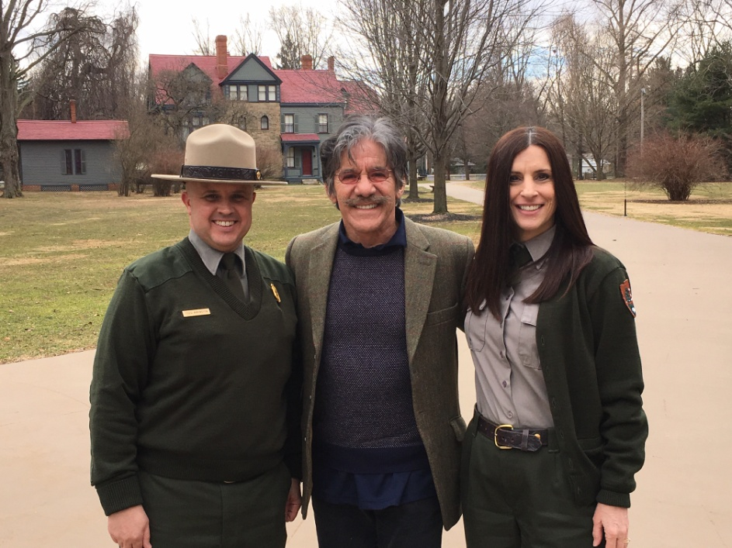

Welcome to the club! John & Tena Kegg of Painesville.
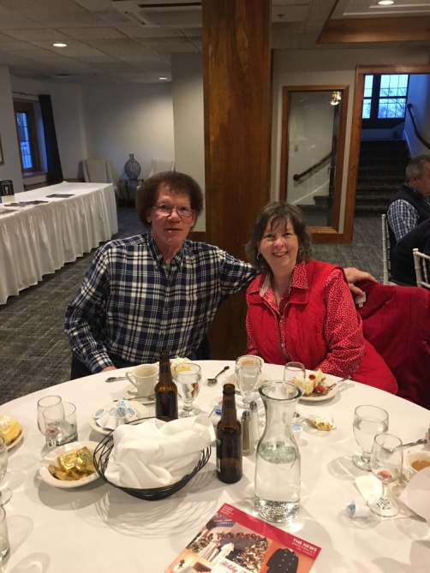

CIVIL WAR JOURNAL of Franco M Sperrazzo

February 12th Meeting, Norton J. London: Kate Chase, Civil War Belle of the North & Gilded Age Woman of Scandal. A strong attendance of 40 members/guests were on hand as Co-founder Norty produced a life tapestry of Kate Chase (daughter of Salmon Chase). Norty chronicled Ms. Chase life of prominence and her influence in her father’s career as Secretary of the Treasury and attempts to wins the Presidency. Studying the life of the charismatic Kate Chase must have been an exciting venture for Norty to research as he took us back to another controversial period in American politics.
March 12th Meeting, Lucretia Garfield (Debbie Weinkamer) & General James A. Garfield (Dan McGill) “Letters from the Homefront”. Debbie has volunteered at JAGNHS since 1998 and has been portraying Mrs. Garfield since 2001. Dan McGill began last year at the Civil War Encampment. The duo shared selected letters and diary excerpts exchanged during Garfield’s service in the Civil War. We had a solid turnout as we enjoyed the first person stellar performance from our friends at JAGNHS.
Mentor Public Library - “Leaders and Legacies of the Civil War” Wednesday, April 10, Noon. Topic: Lincoln Assassination - The President was cautiously hopeful for America’s future to “Bind up the nation’s wounds” when he went to Ford’s Theater of April 14, 1865. John Wilkes Booth felt differently as a plan to kidnap the President ended up as an act of murder. This outrageous act destroyed any hope for reconstruction. Presented by Dr. Todd Arrington of the JAGNHS and fellow NEOCWRT member.

NEOCWRT 2019 MEMBERSHIP DUES: If you haven’t paid yet, please do so at our April Dinner. $55 Single $75 Couple

From the Editor
Please Share Your Opinions

The Program Committee will be doing a survey at our April meeting. We ask that you please participate. When you check in, you will receive a questionnaire asking your opinions on our Confederate flag and our dinner programs. This can be done at your leisure during the evening. When you have completed your questionnaire, please place it in the survey box which will be located near the door. Thank you.

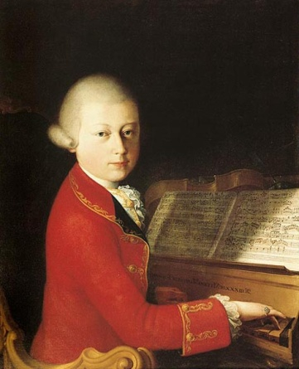
Wolfgang Mozart (1756-1791): “That’s good advice”
Admirer: "Herr Mozart, I am thinking of writing symphonies. Can you give me any suggestions as to how to get started?"
Mozart: "A symphony is a very complex musical form. Perhaps you should begin with something simpler."
Admirer: "But Herr Mozart, you were writing symphonies when you were 8 years old."
Mozart: "Yes, but I never asked anybody how."

All articles appearing in the Courier do not necessarily state or represent an endorsement of the facts, conclusions, and opinions of the author(s) by the NEOCWRT or its membership.

